**Submitted By: Aditya Raj**

**Submitted To: Dr. Vandana Kanotra**

**Roll: 2438108**

**Course: B.Tech – CSE**

**All the files are uploaded at GitHub:** [GitHub/Adii-Raj/fwd_task](https://github.com/Adii-Raj/fwd_task)

* Write HTML code to create the unordered list.

HTML Code:

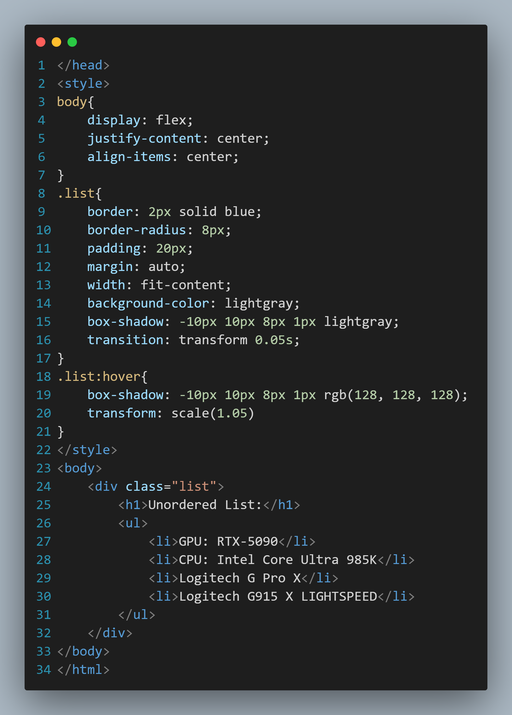

Result:

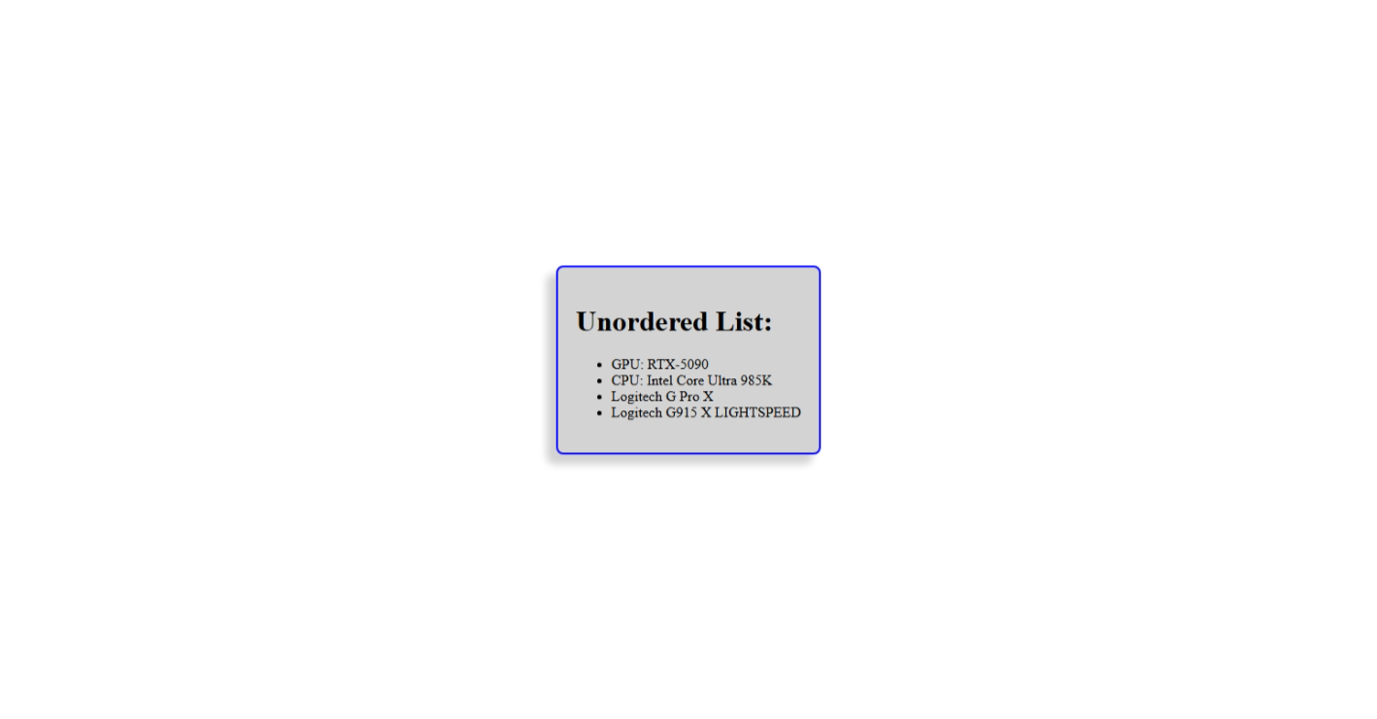

* Write HTML code to create the ordered list.

HTML Code:

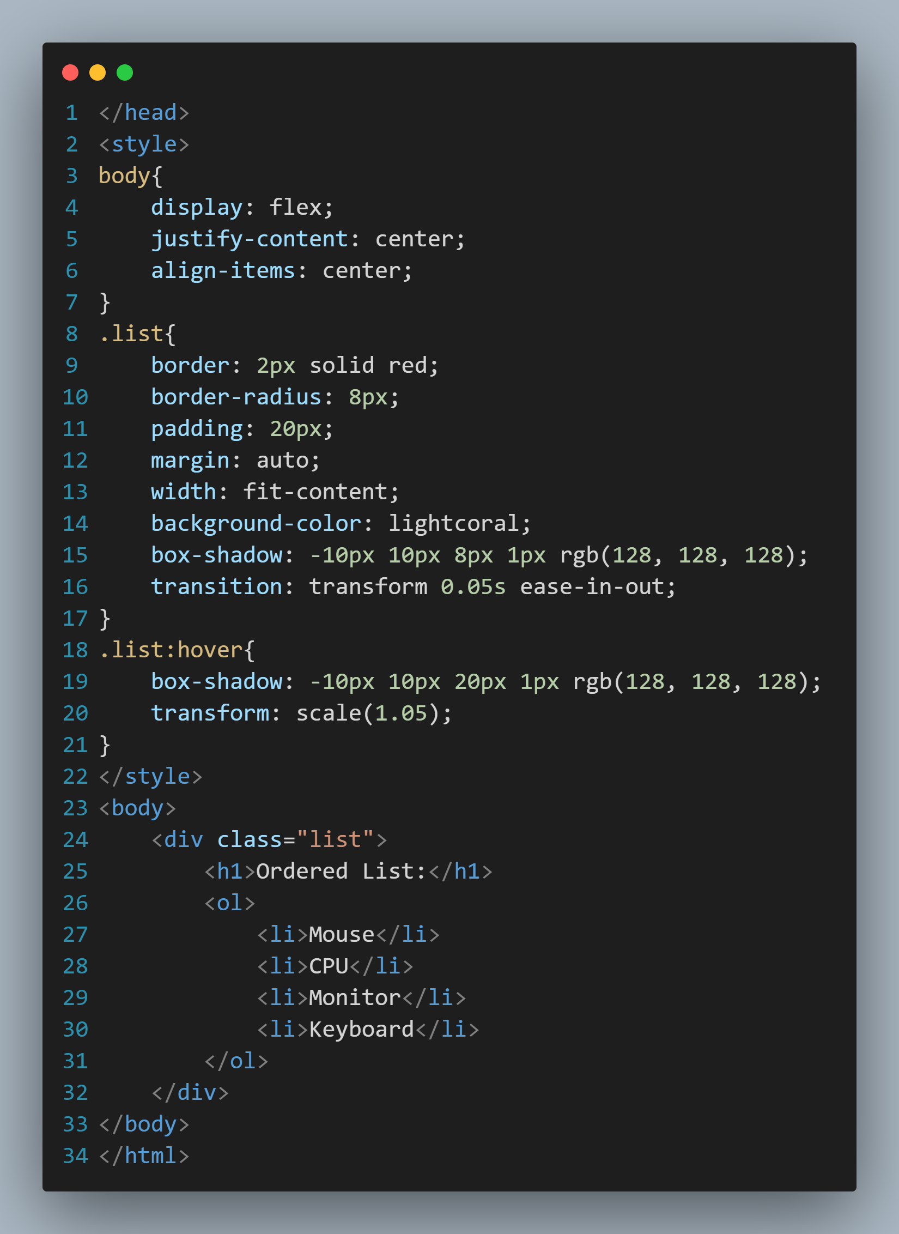

Result:

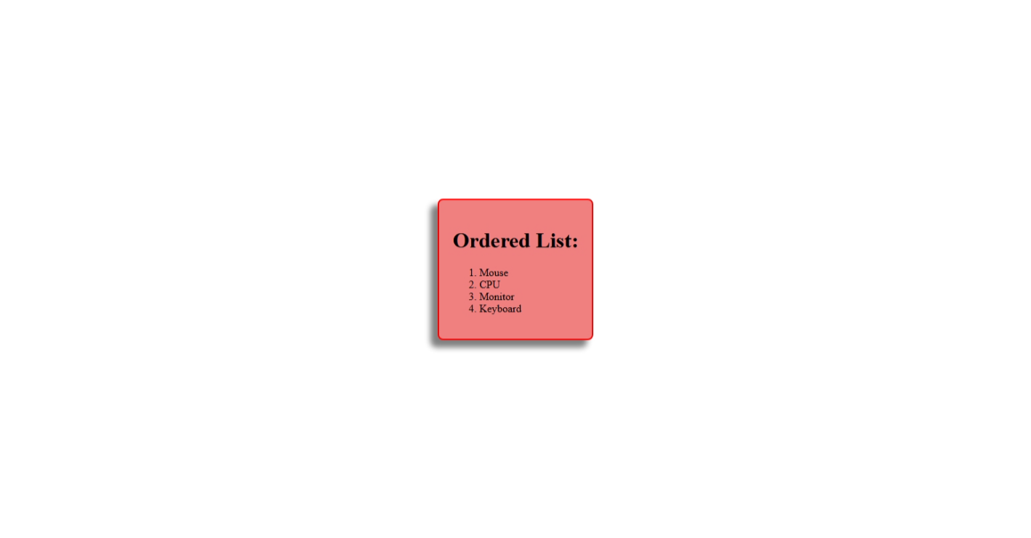

* Write HTML code to create the definition list.

HTML Code:

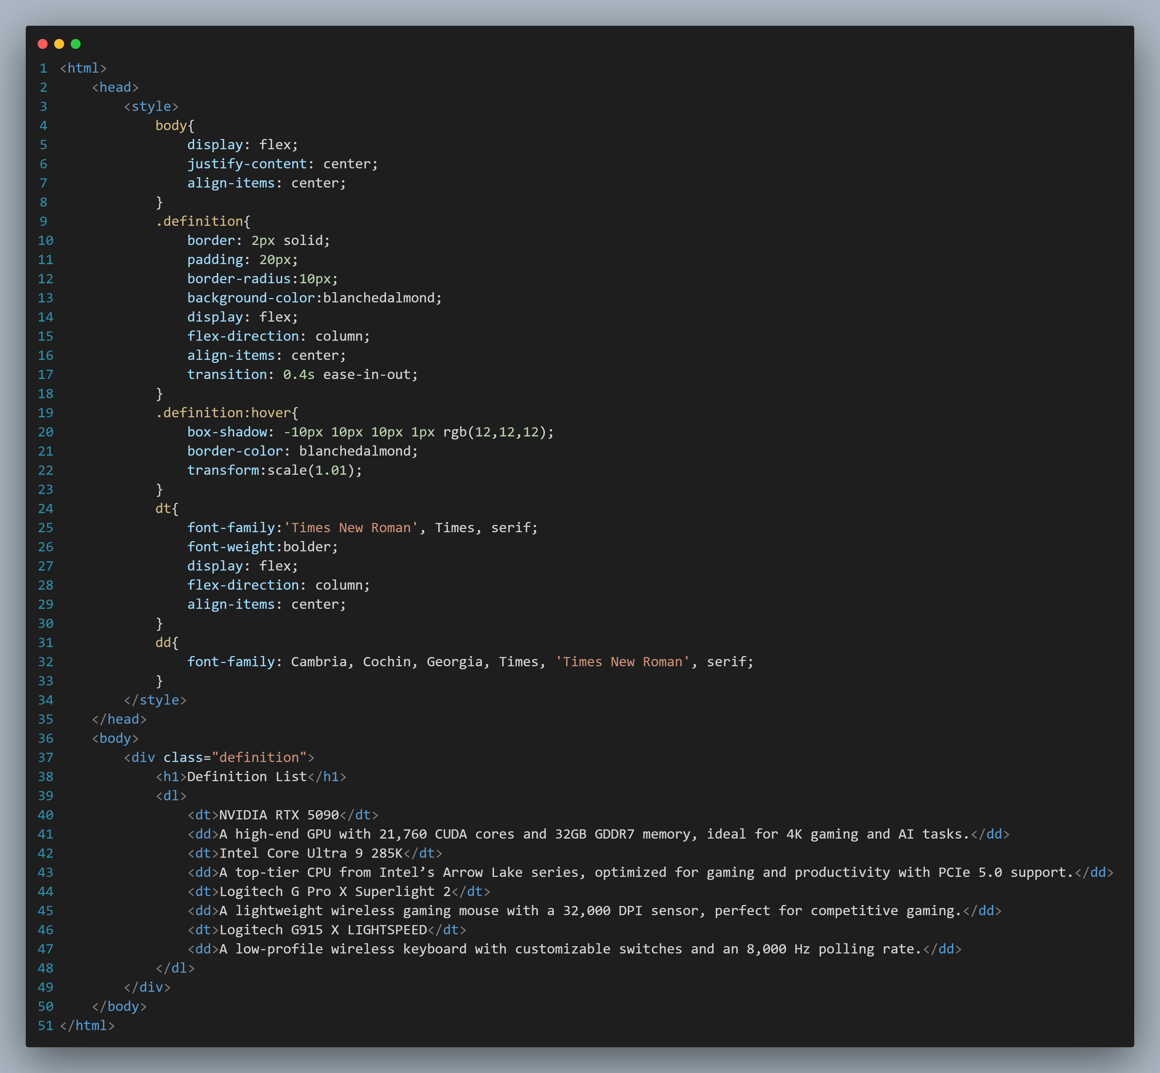

Result:

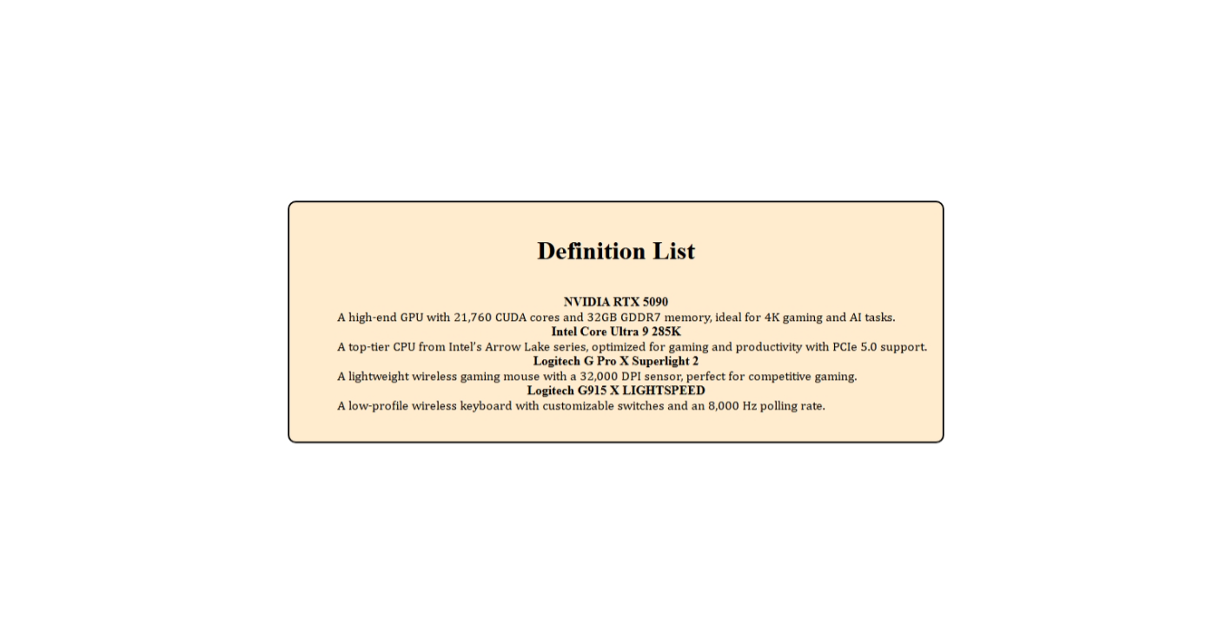

* Write HTML code to insert an image.

HTML Code:

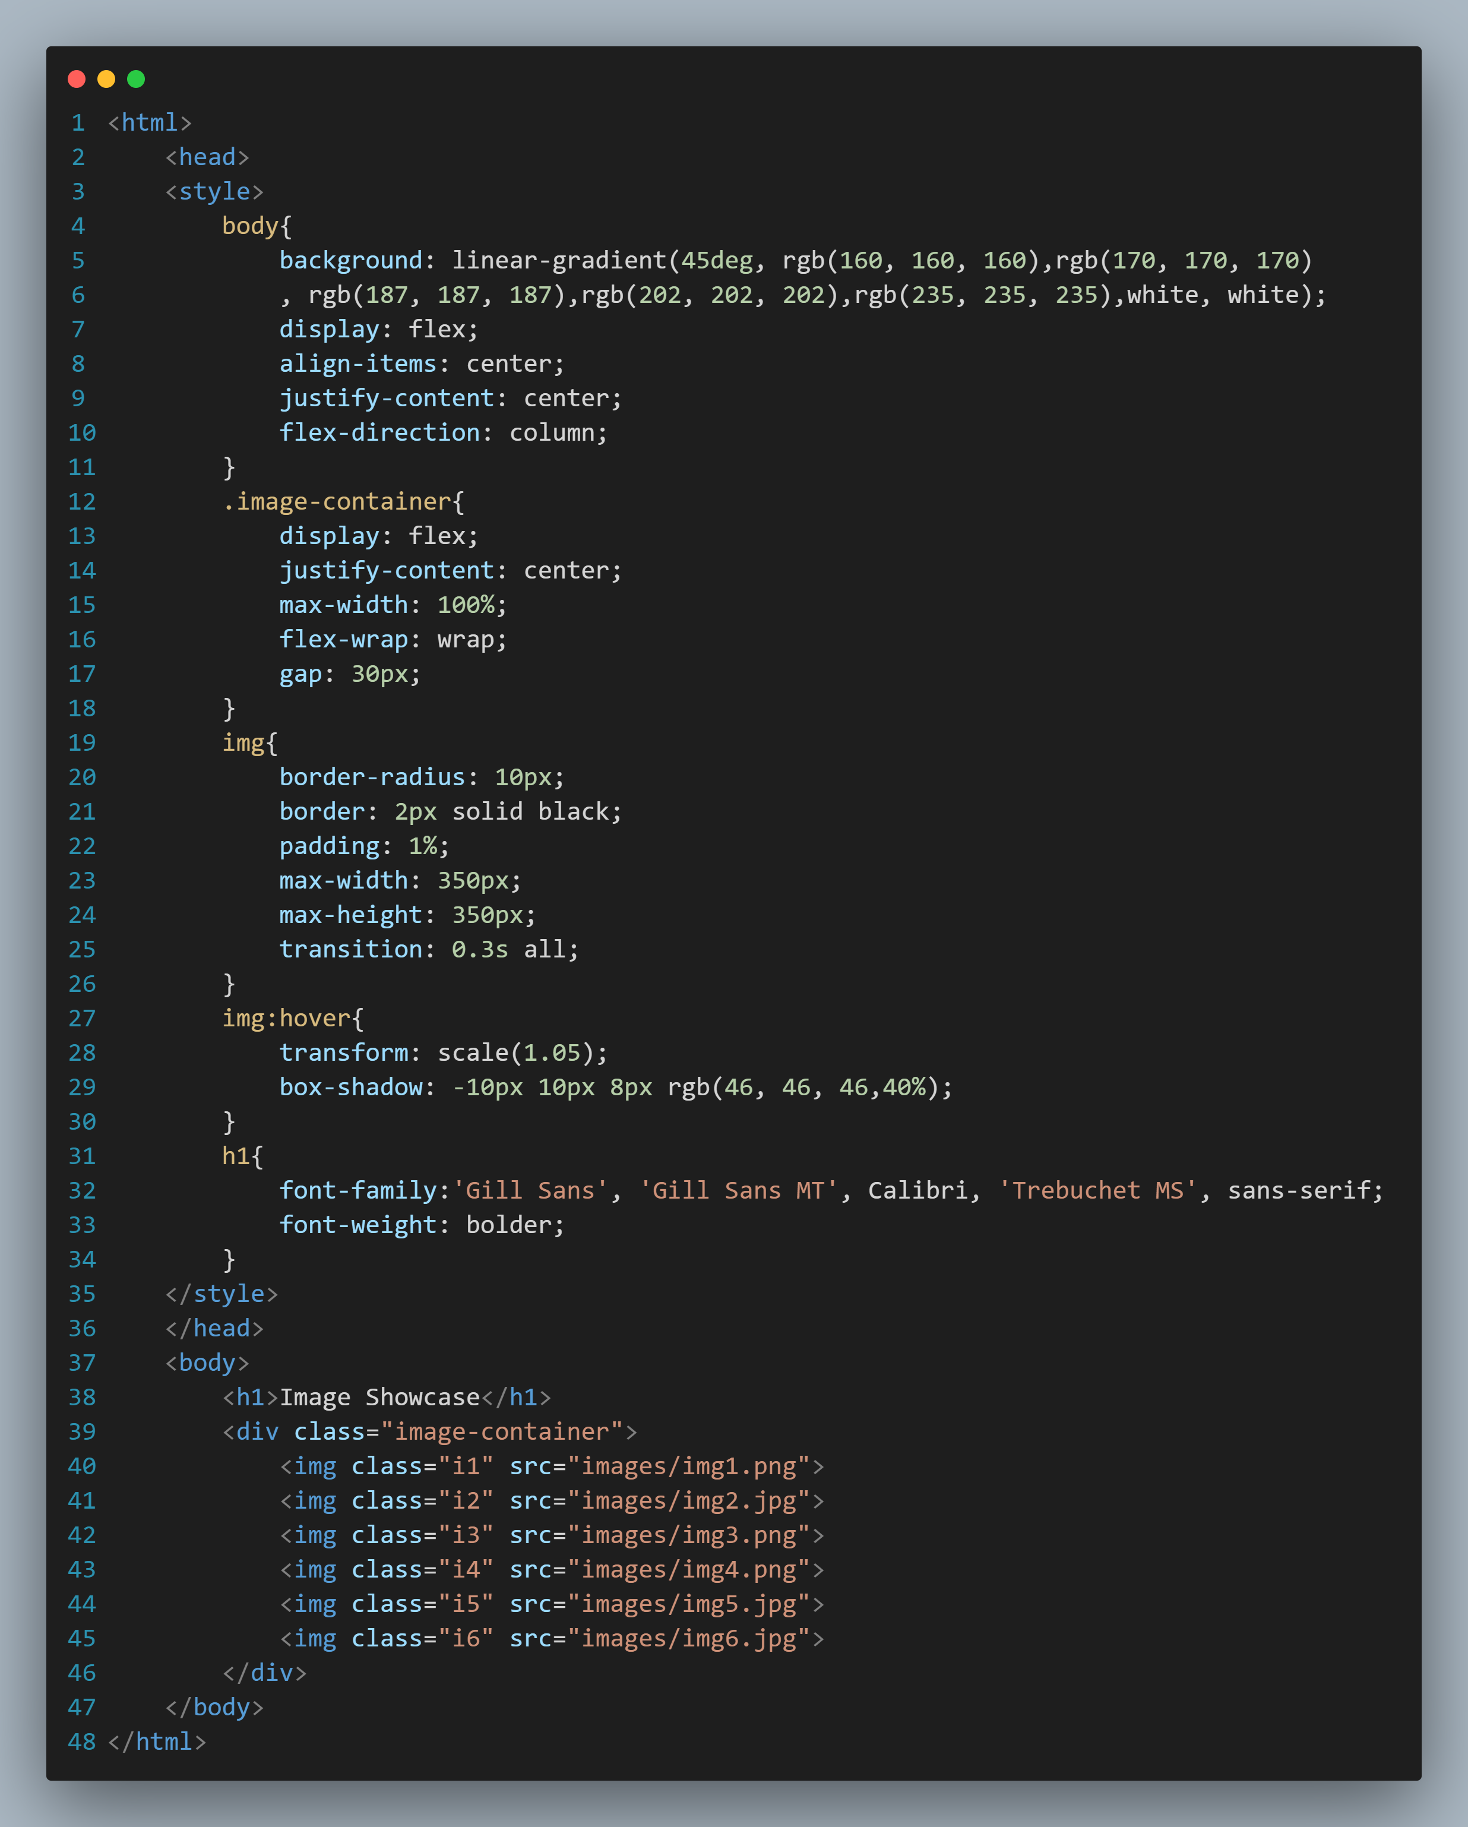

Result:

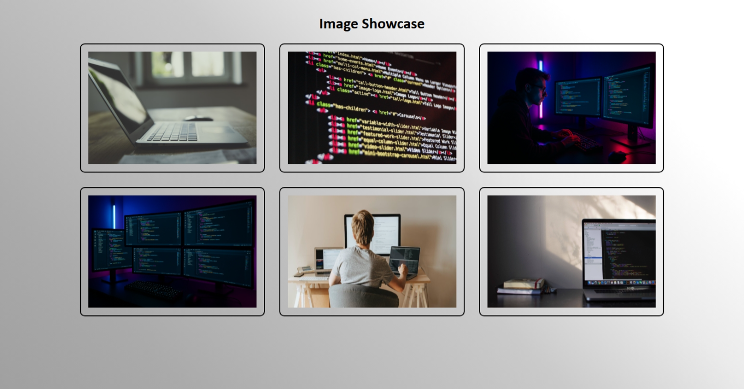

* Write HTML code for placing text between two images.

HTML code:

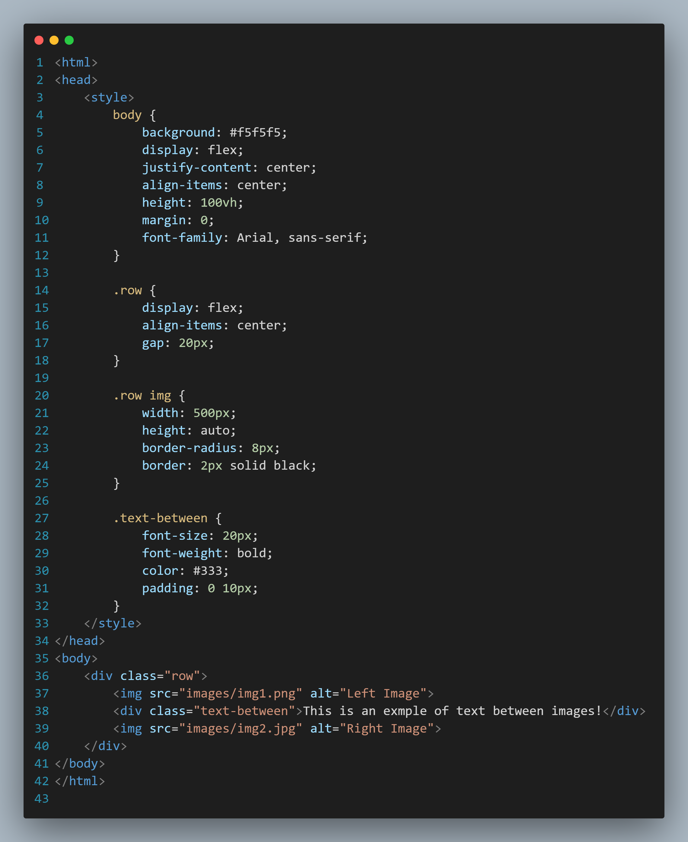

Result:

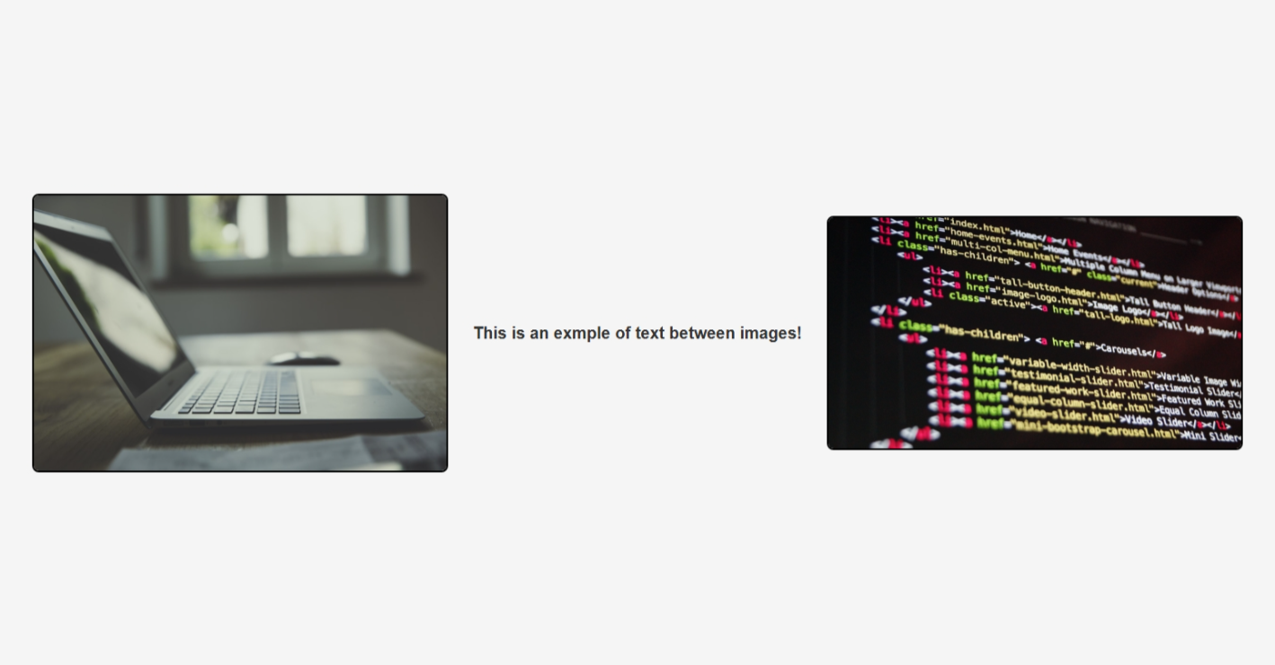

* Write the HTML code for placing images in the corner of html page.

HTML Code:

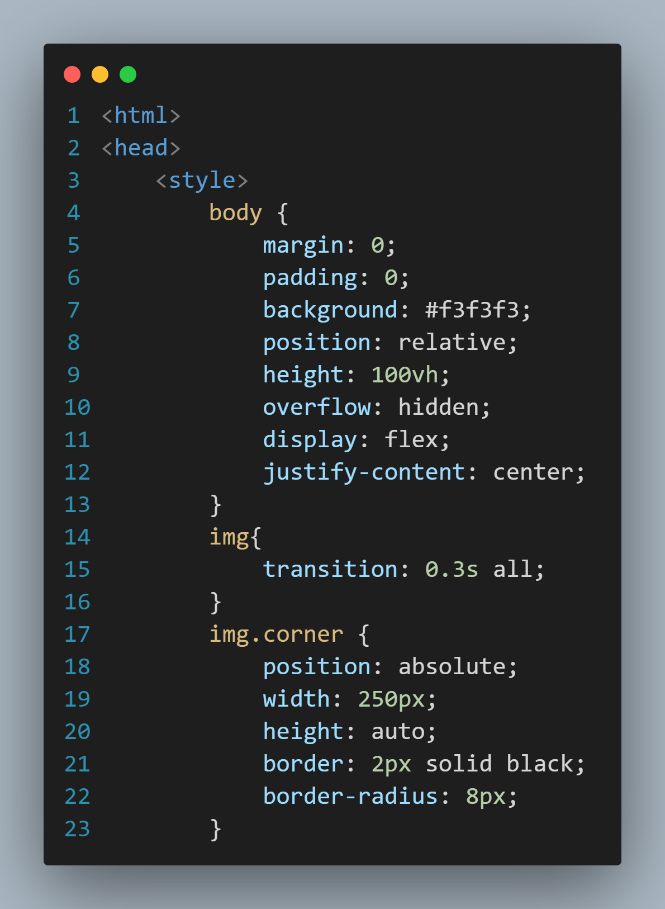

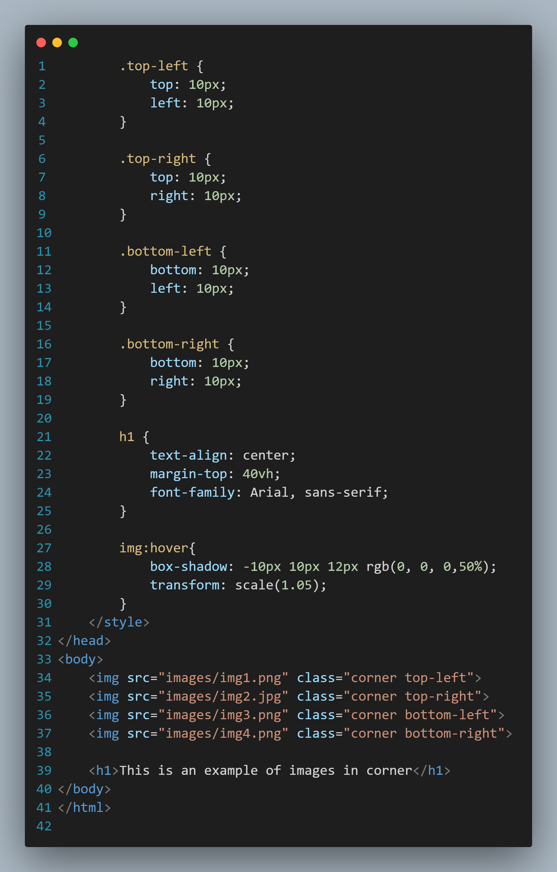

Result: 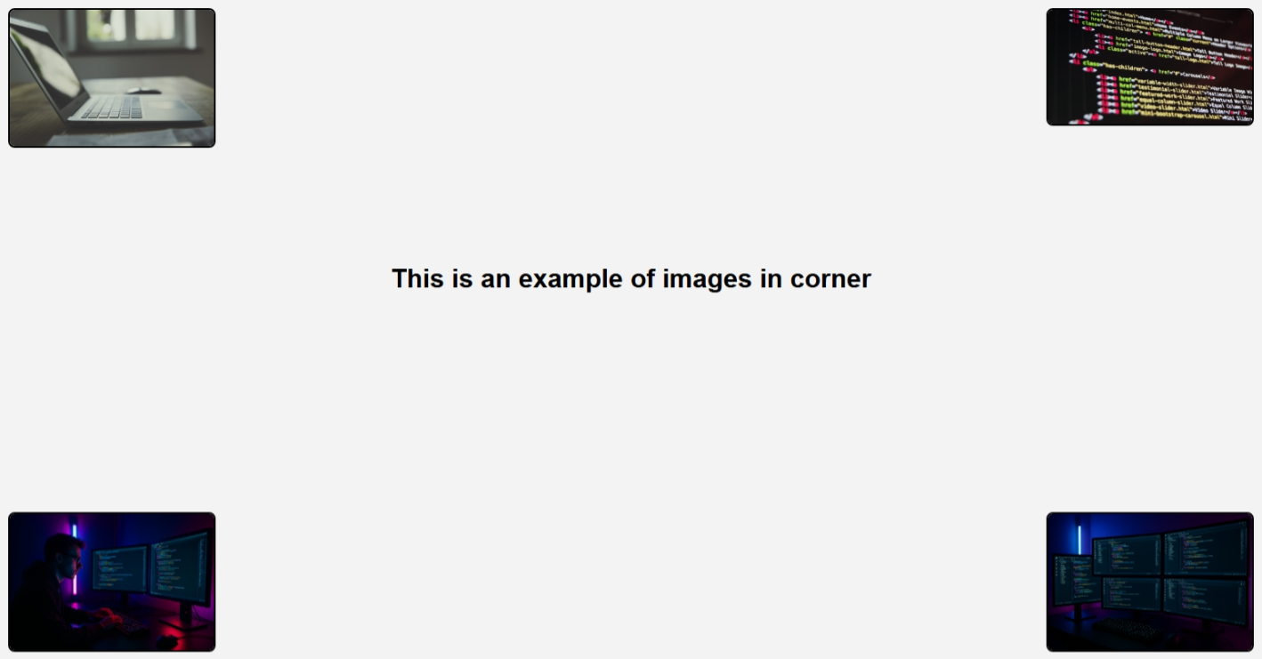

* Write HTML code to display the usage of internal linking on web page.

HTML Code:

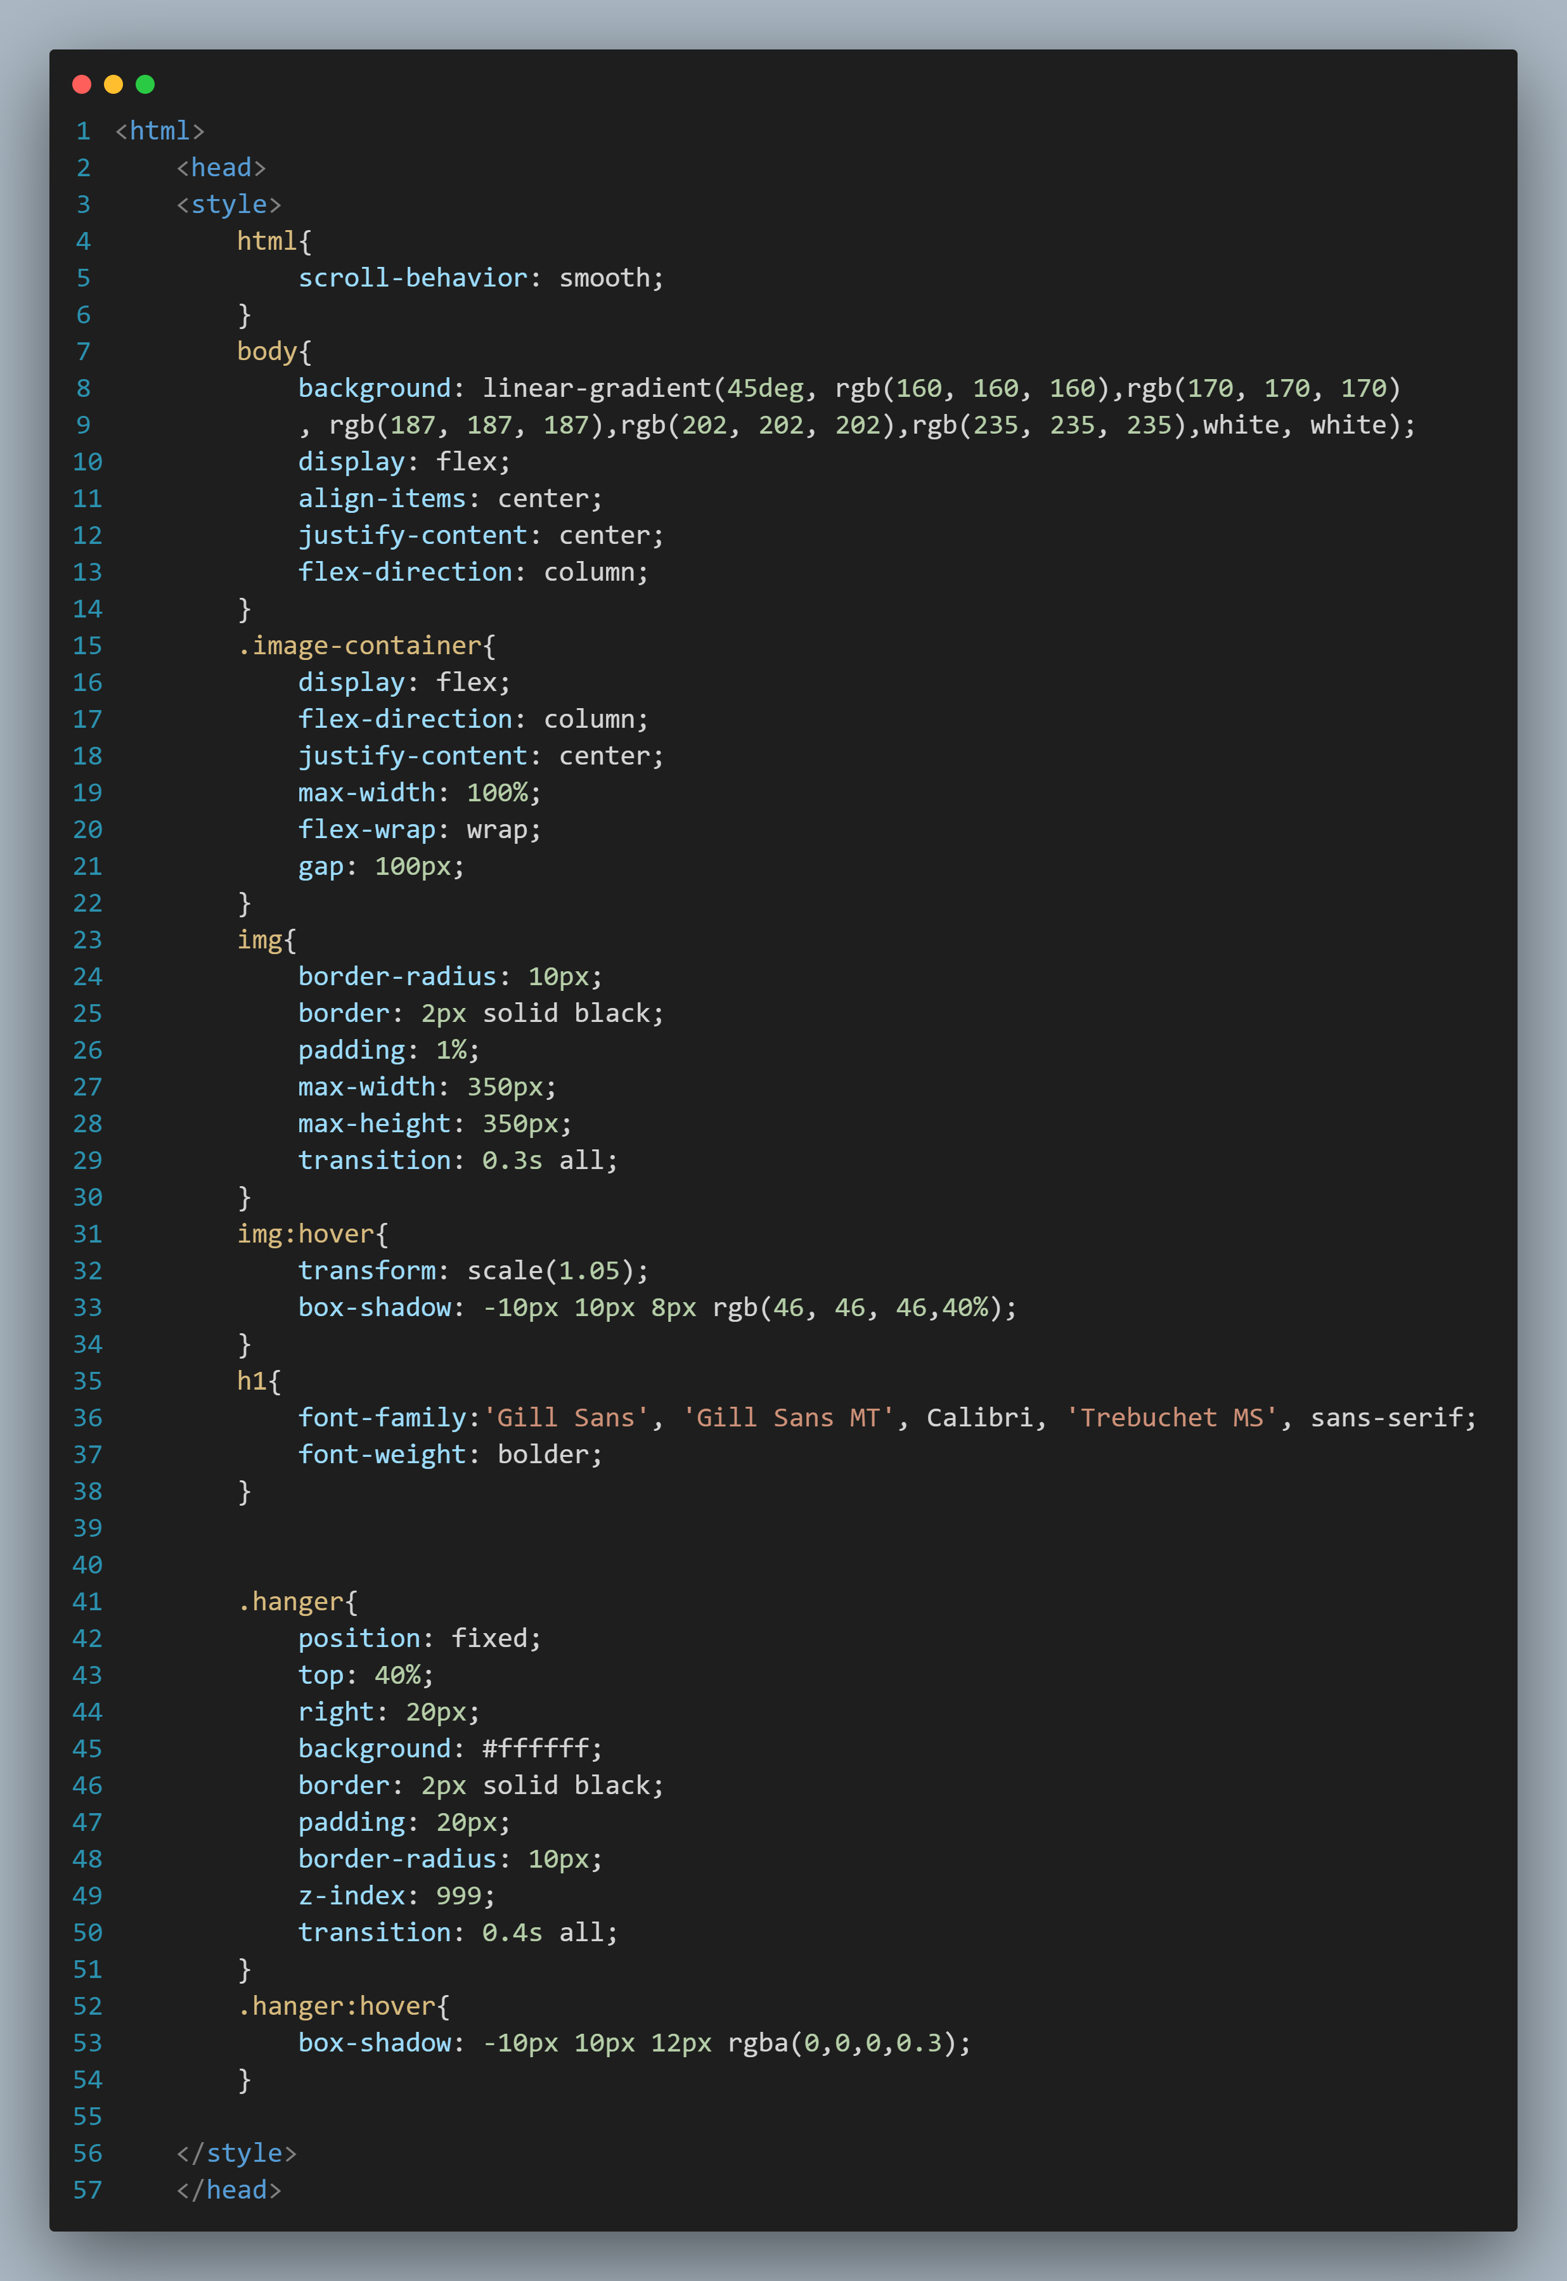

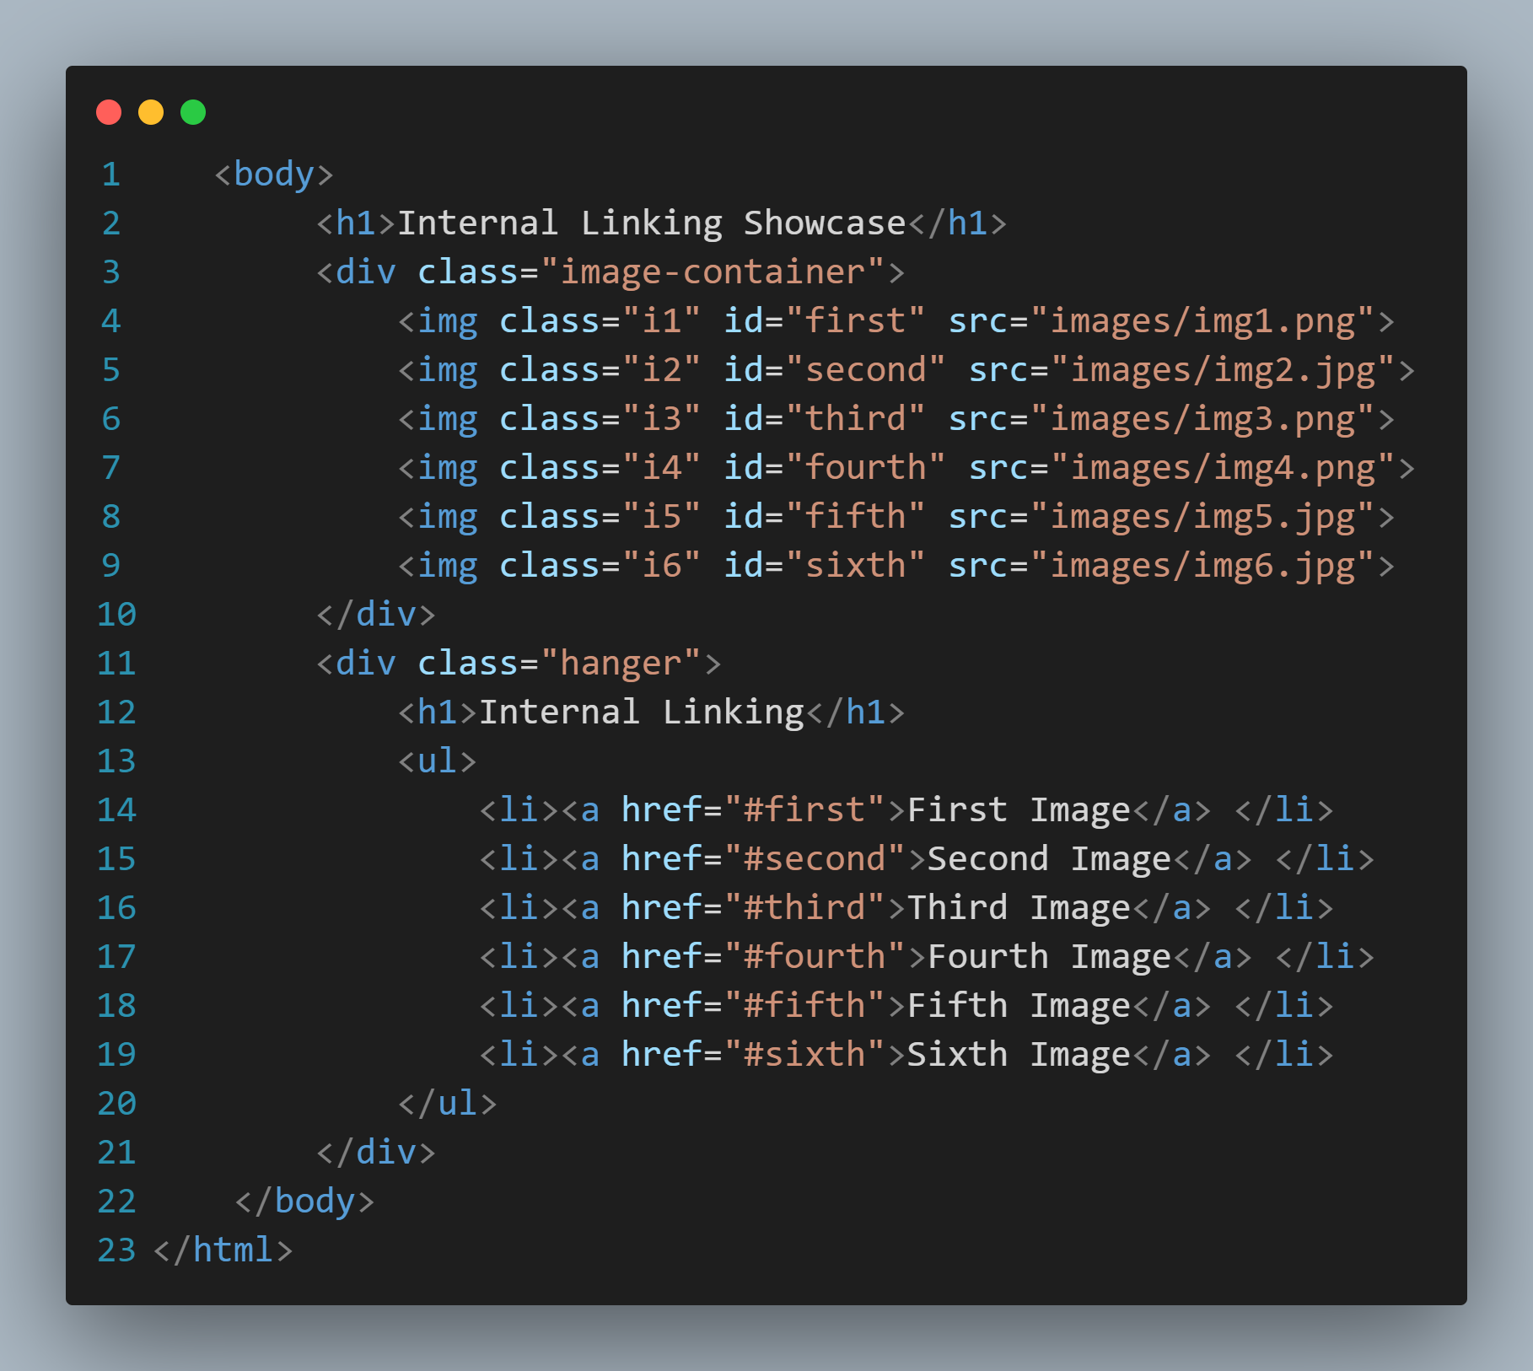

Result:

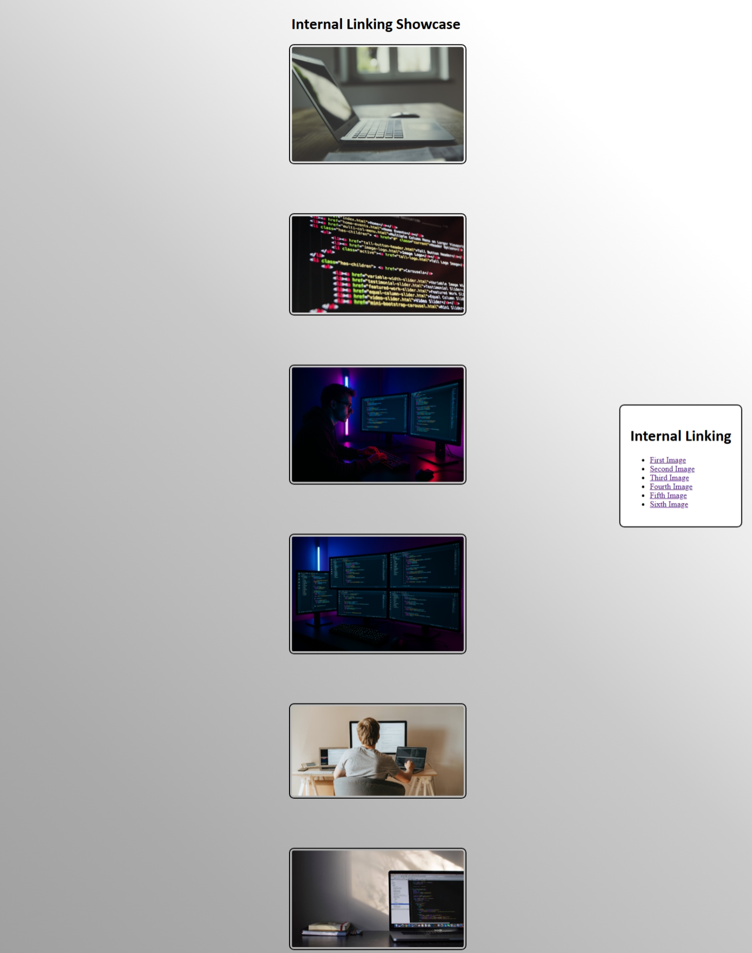

* Write HTML code to display the usage of external linking on web page.

HTML Code:

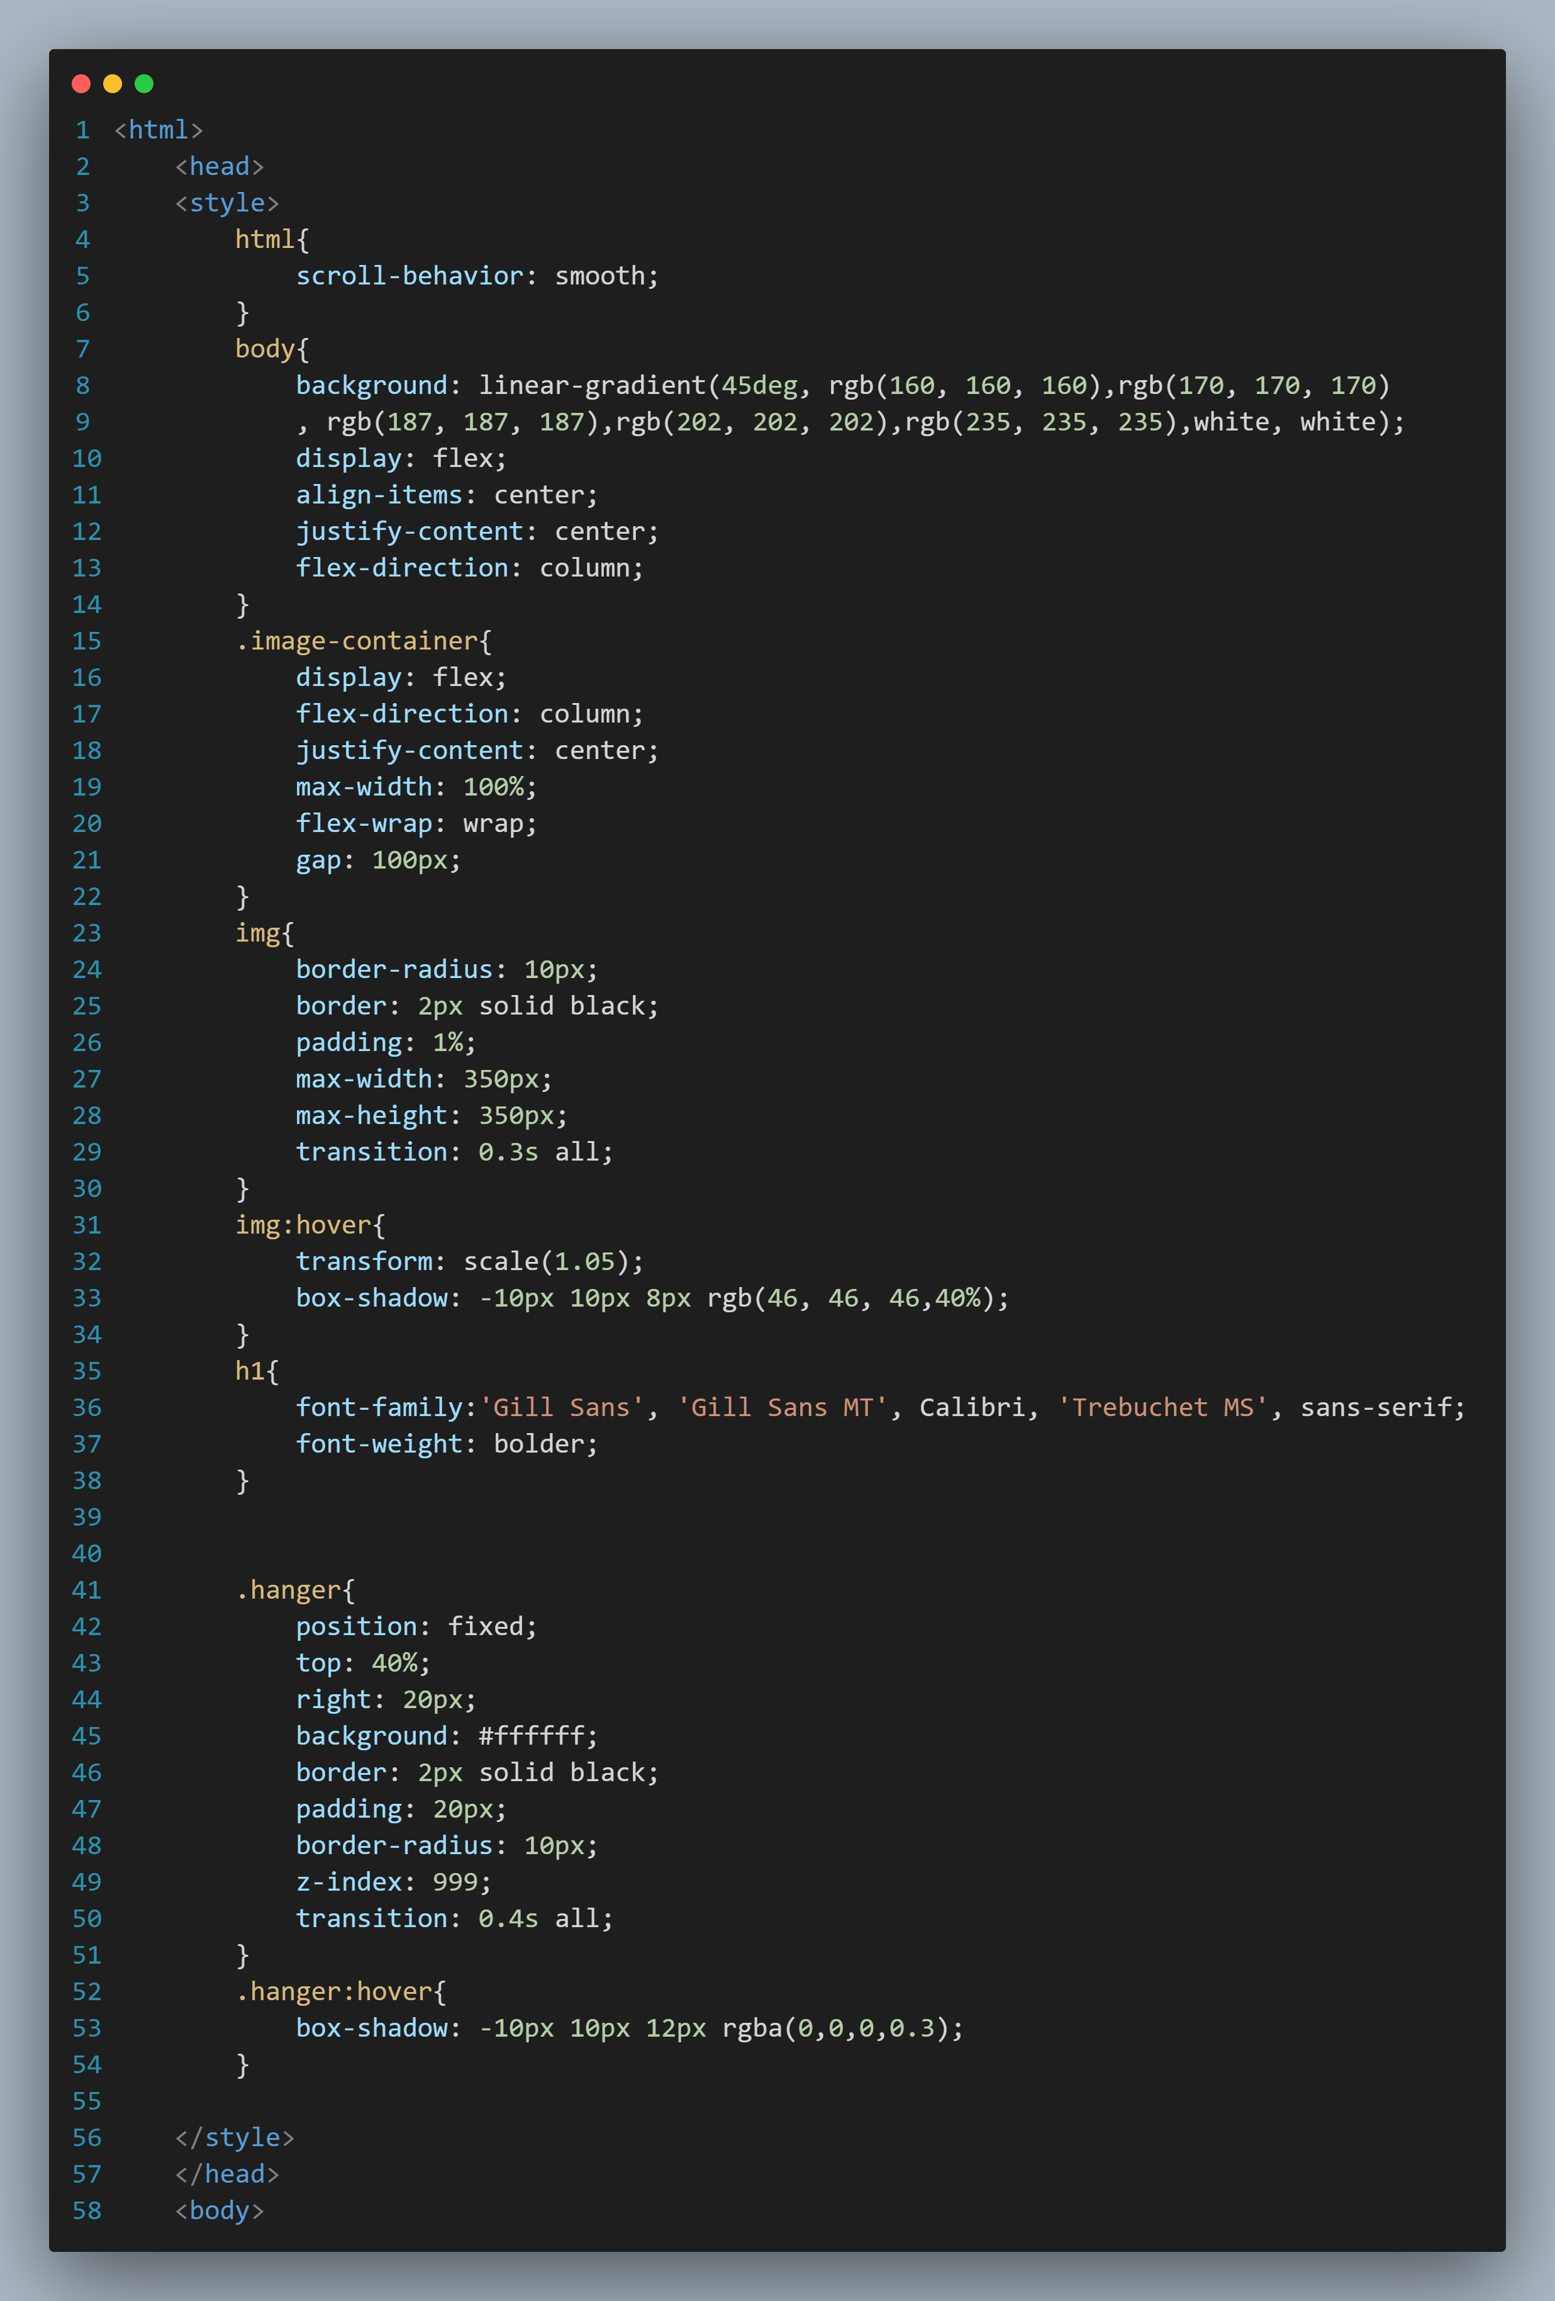

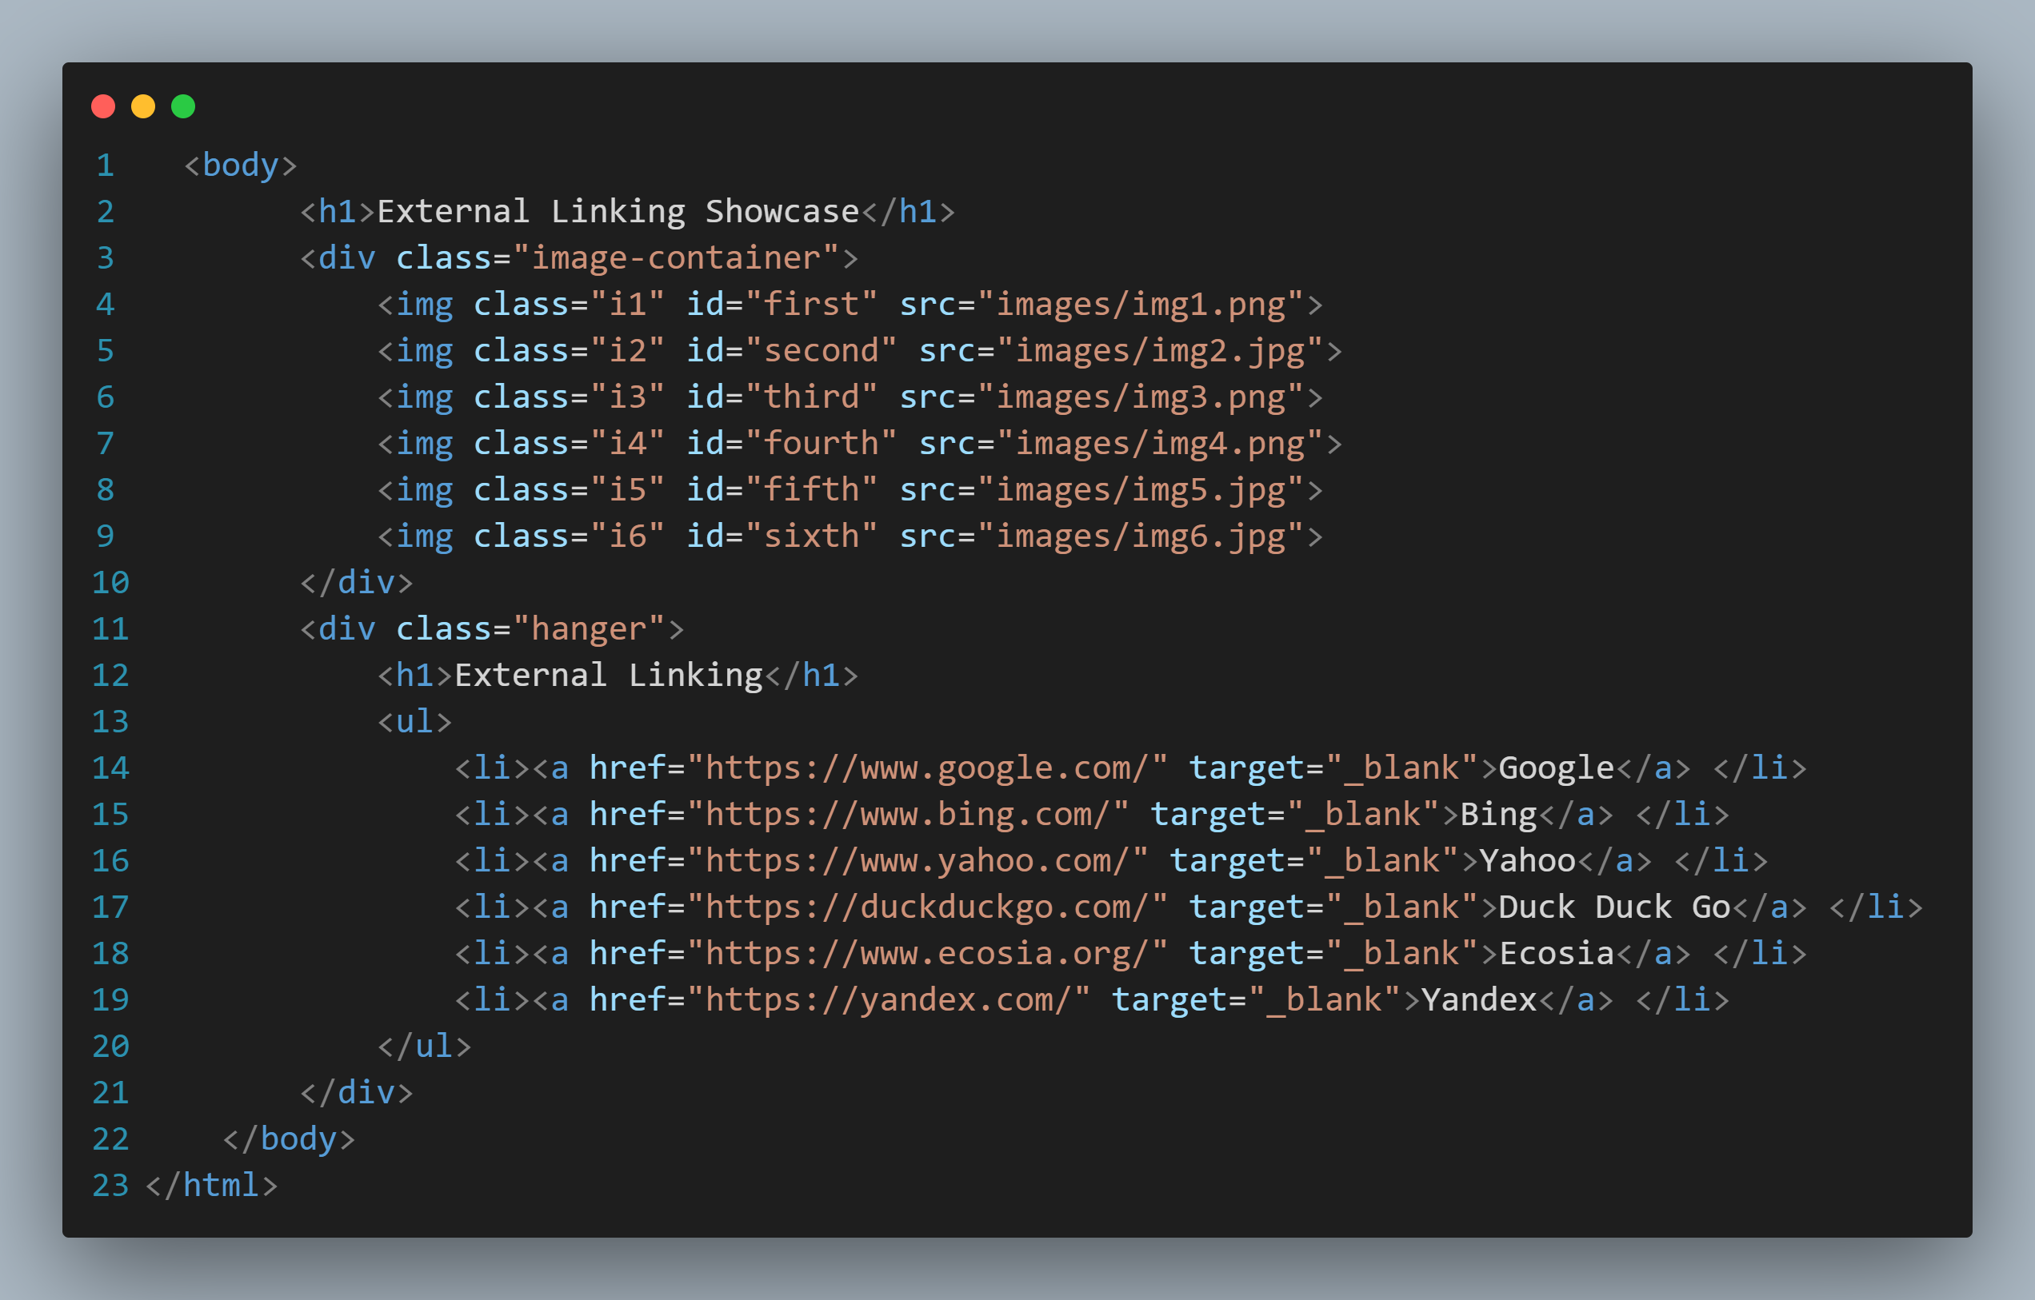

Result: 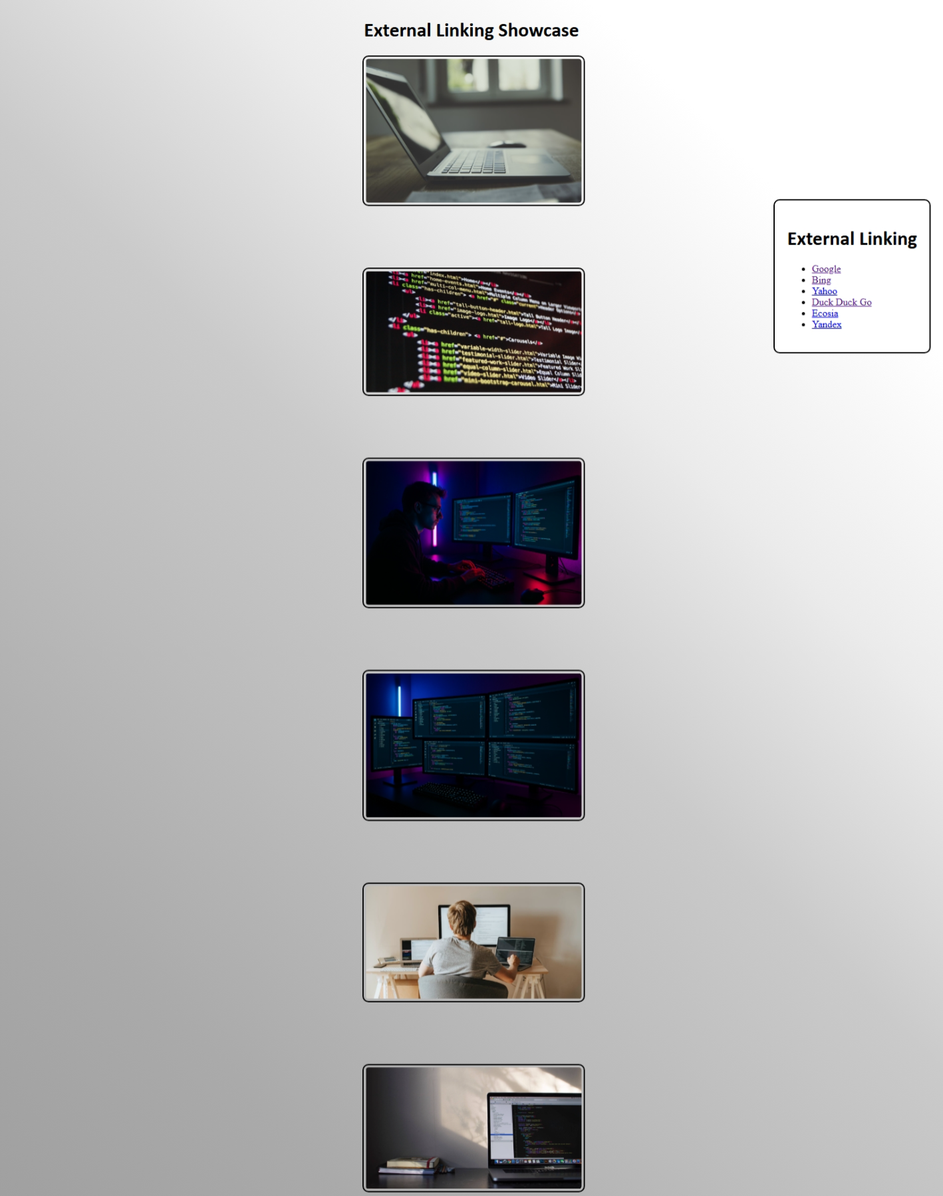

* Write HTML code to generate the board of the chess.

HTML CODE:

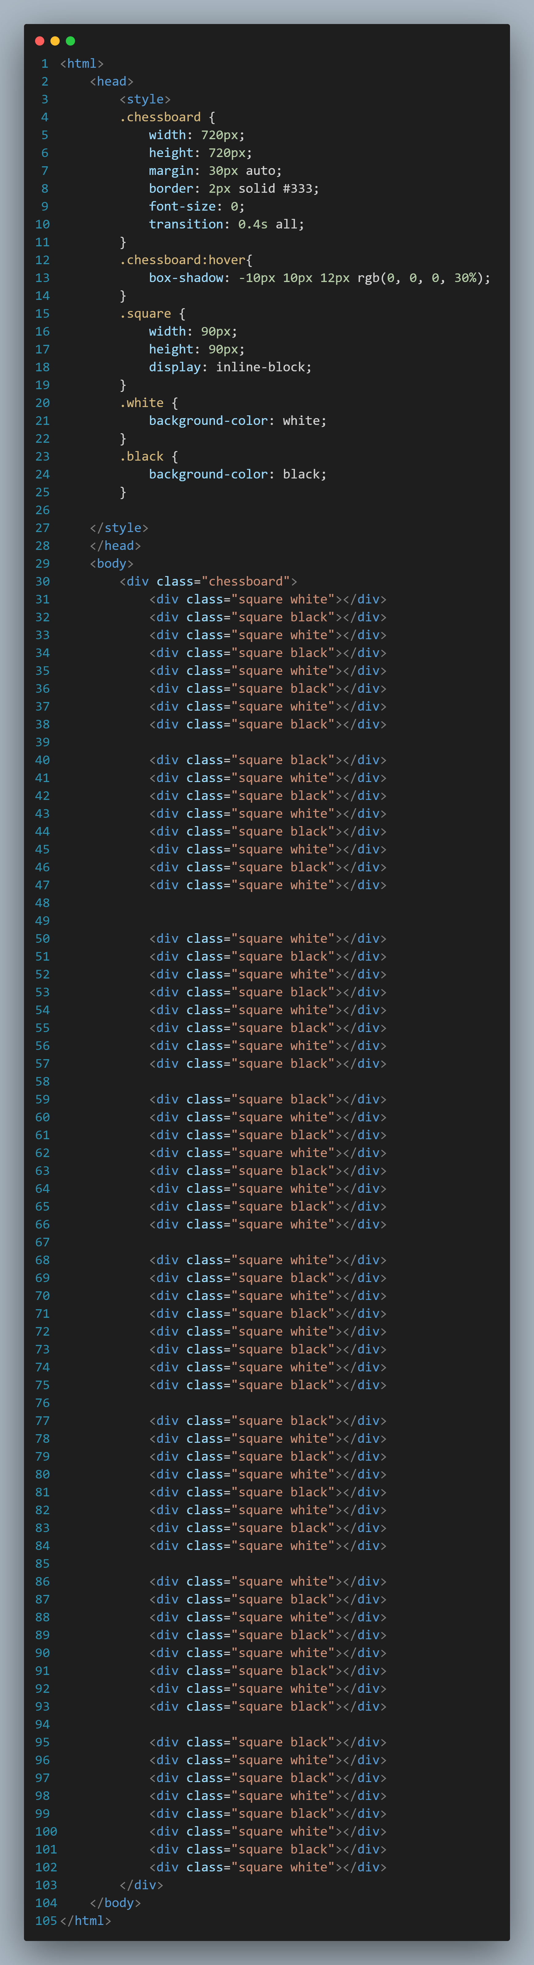



Result:

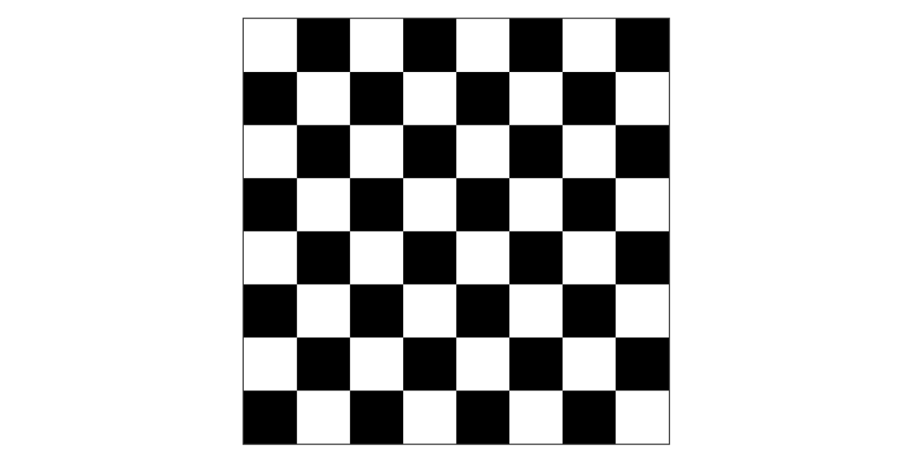

* Write HTML code for creating student table.

HTML Code:

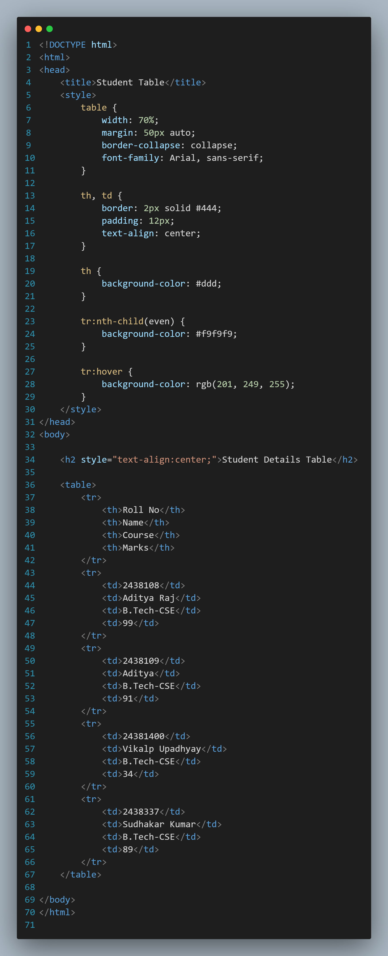



Result:

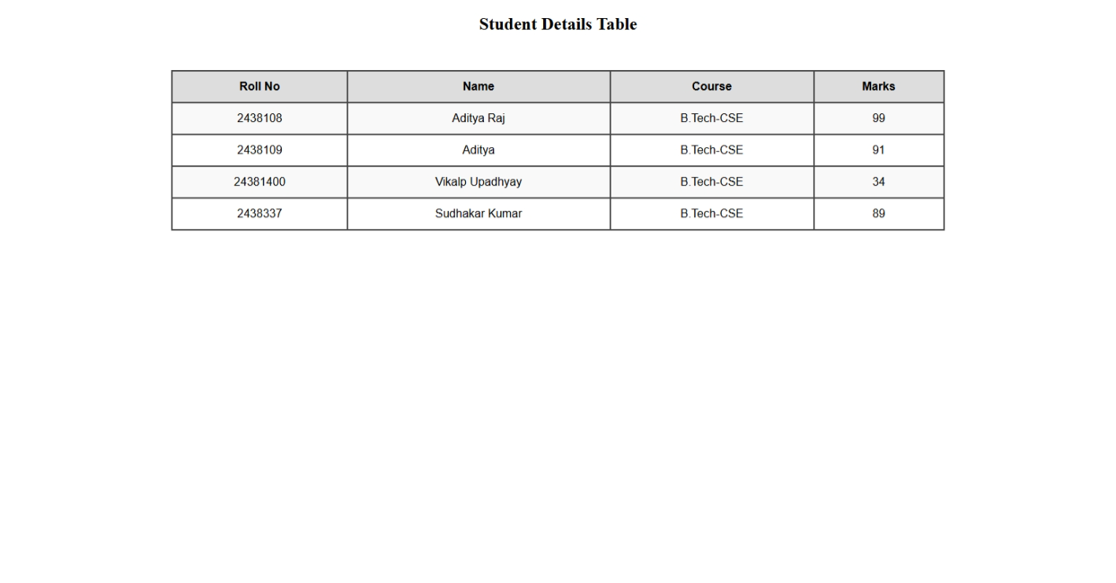

* Write a HTML code to design following table

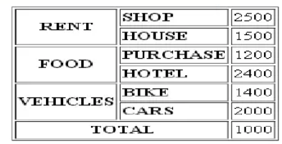

HTML Code:

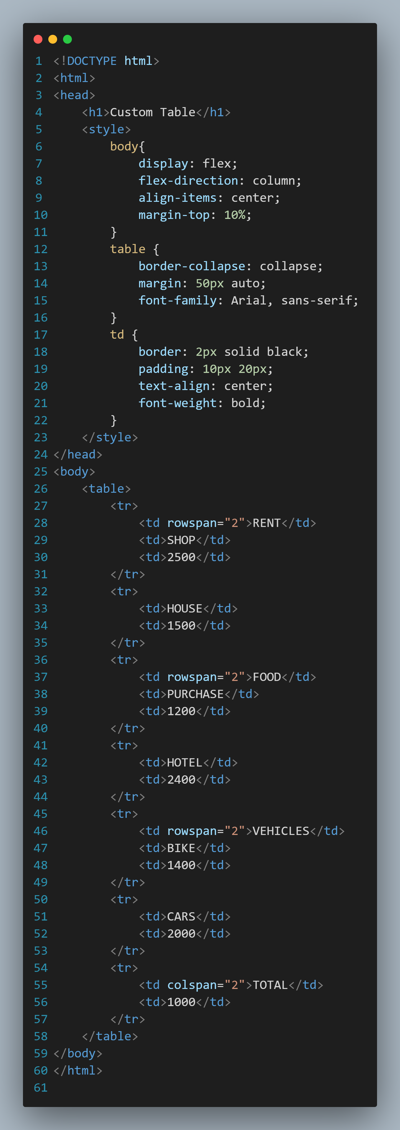



Result:

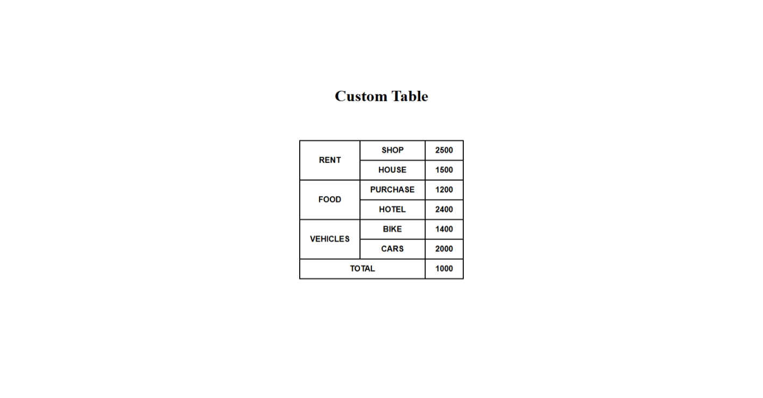

* Write HTML code to design the frame.

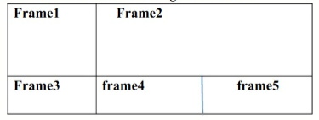

HTML Code:

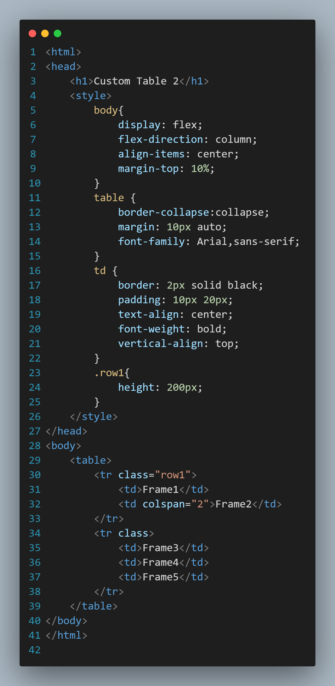



Result:

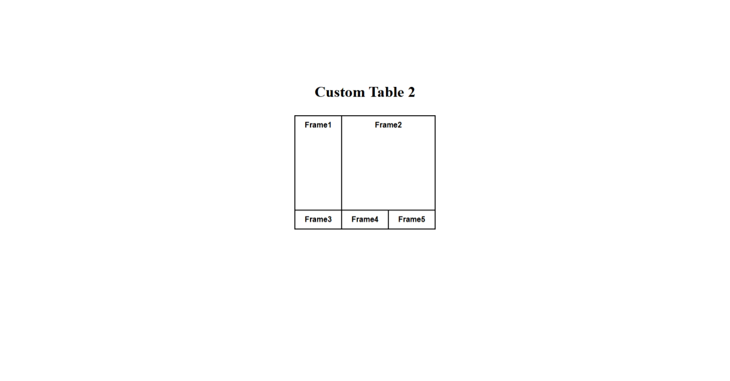

* Write HTML code to create an image map on India map.

HTML Code:

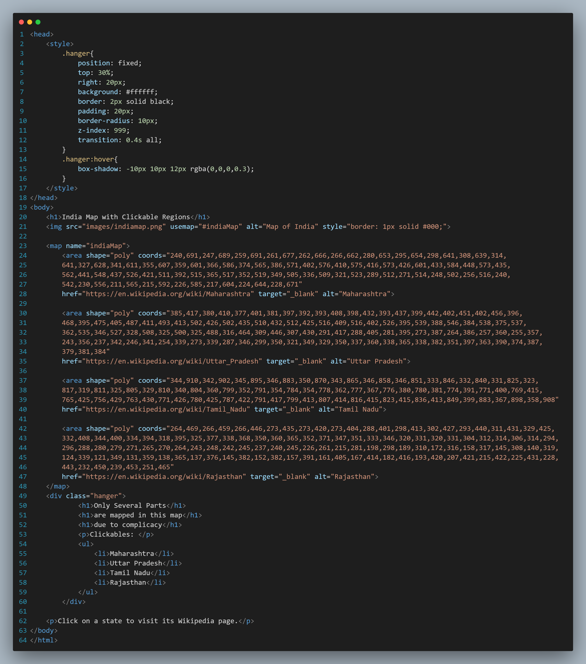

Result:

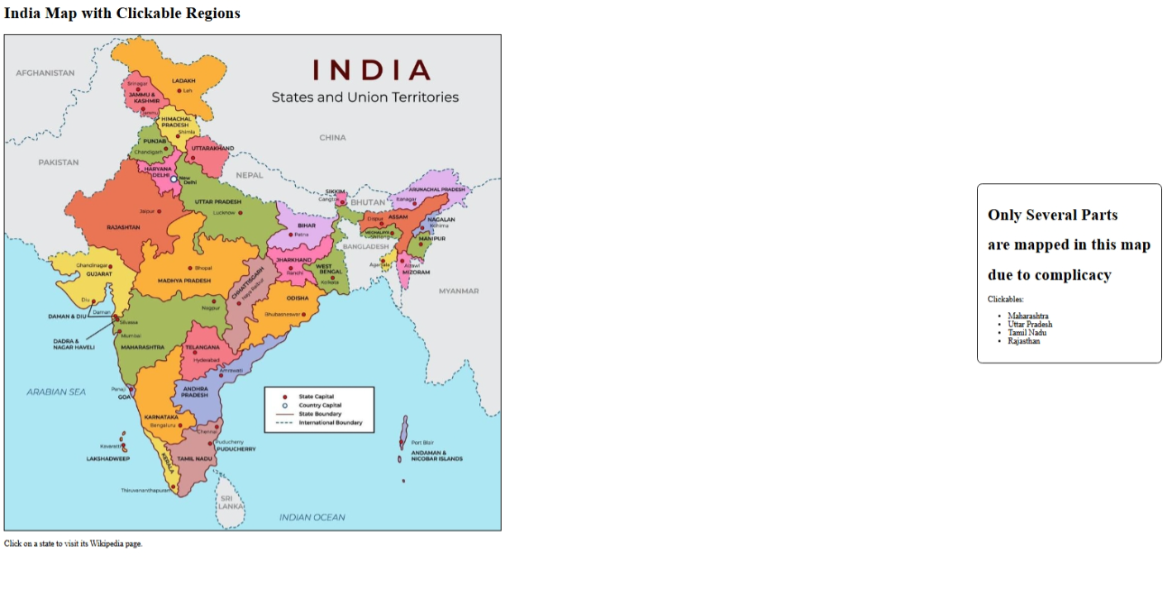

* Write HTML code to create an order form by a customer.

HTML Code:

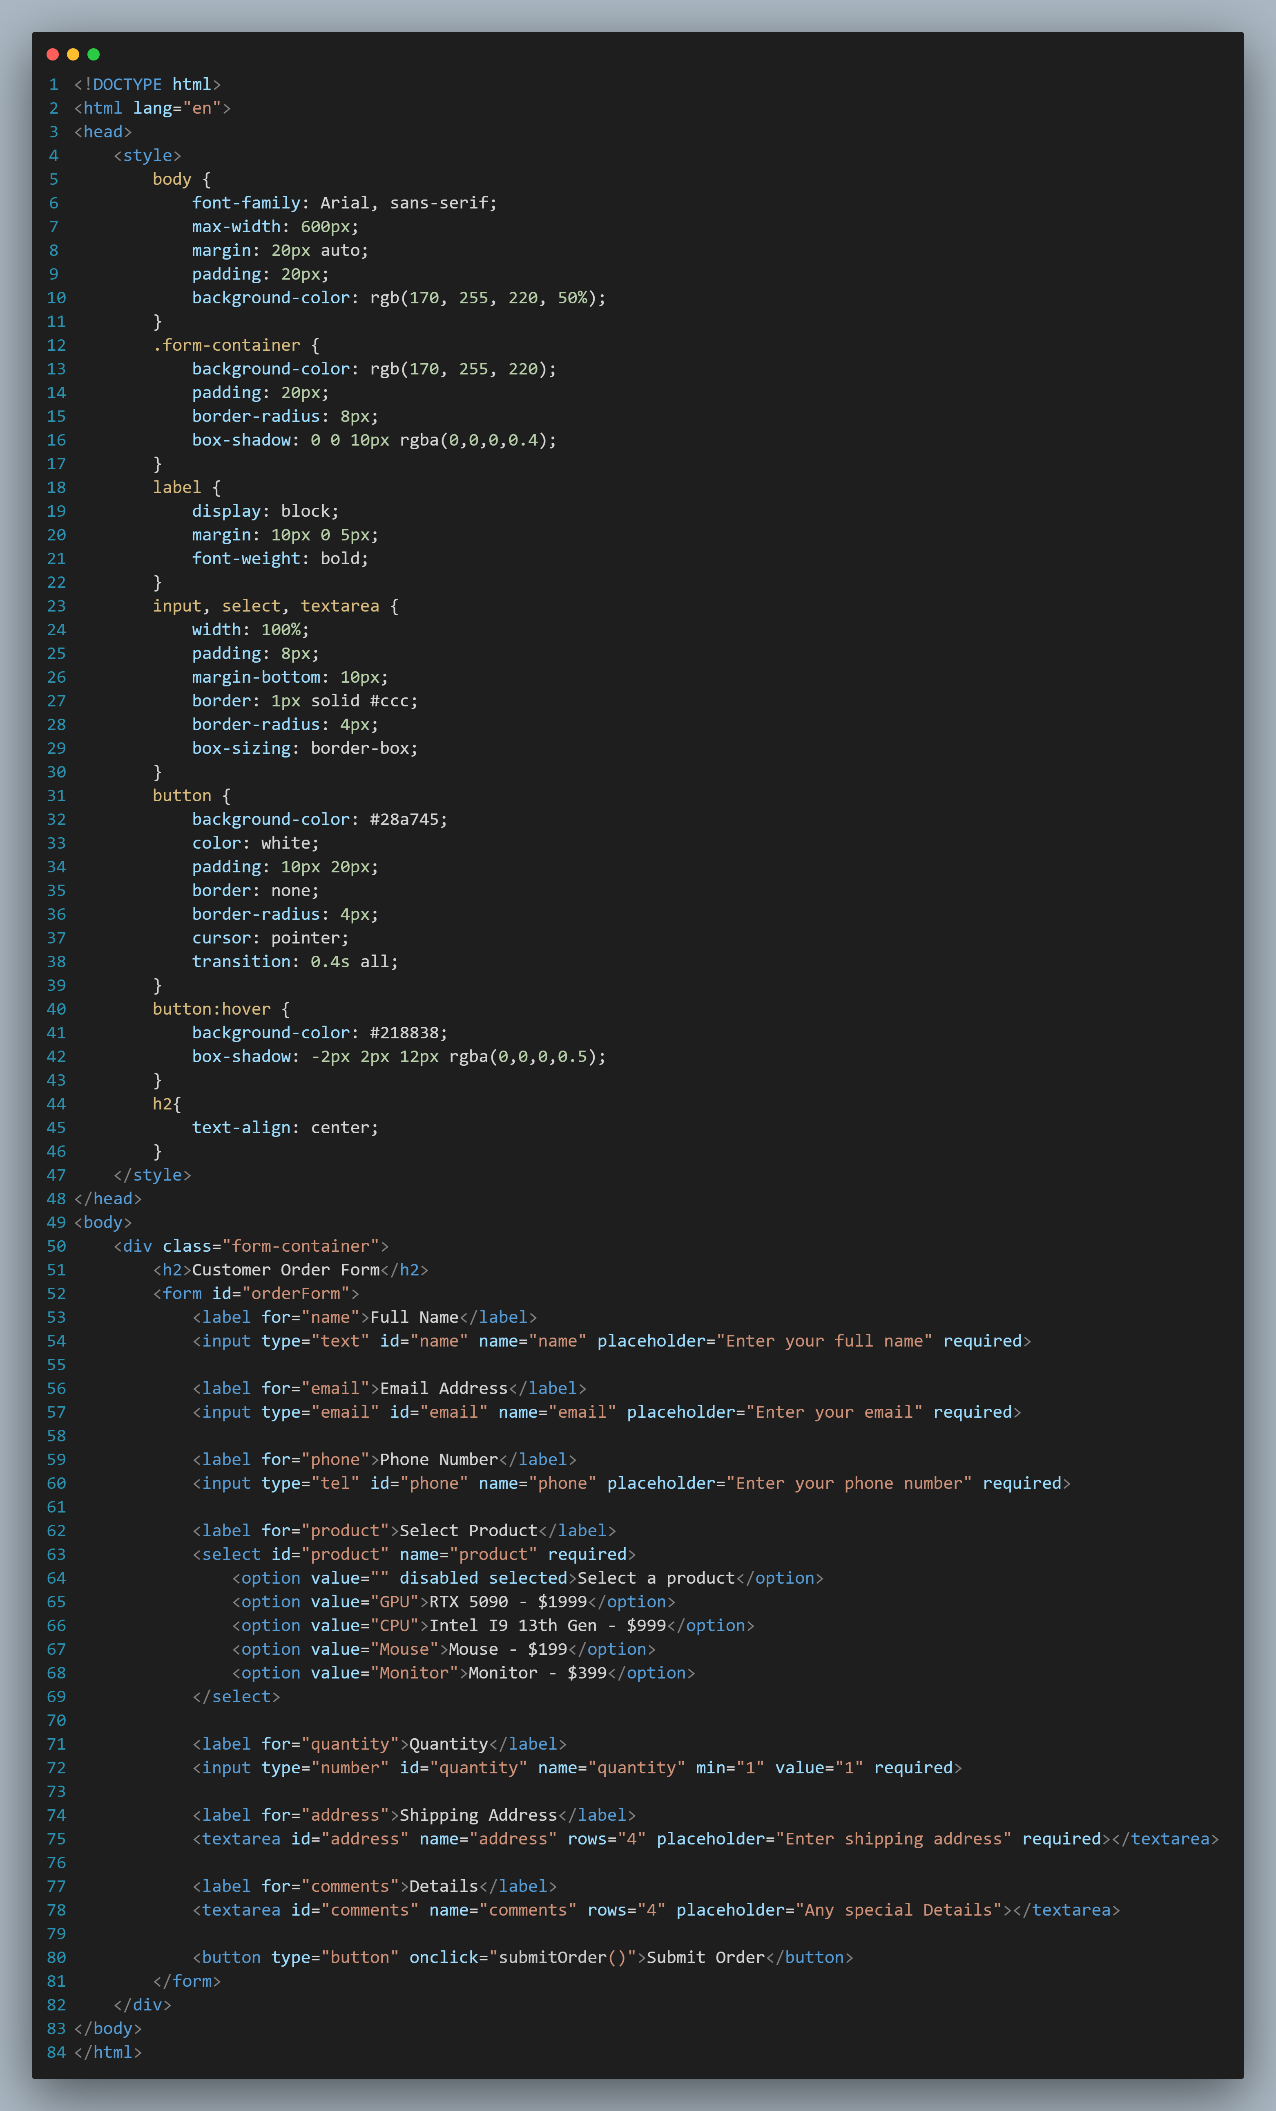

Result:

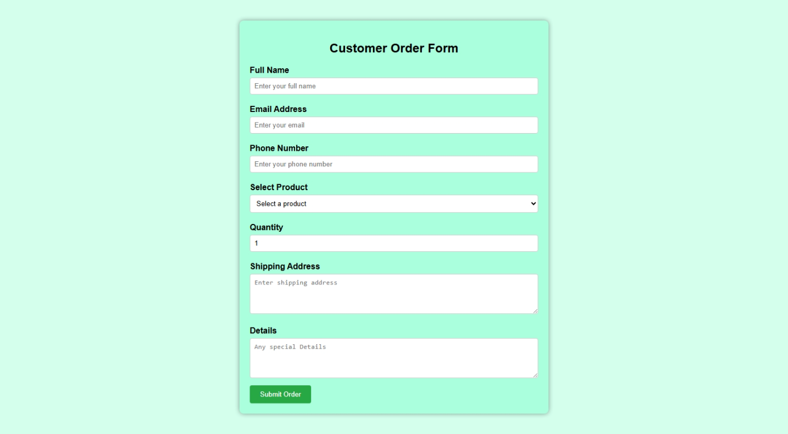

* Write HTML code to display application form by an employee.

HTML Code:

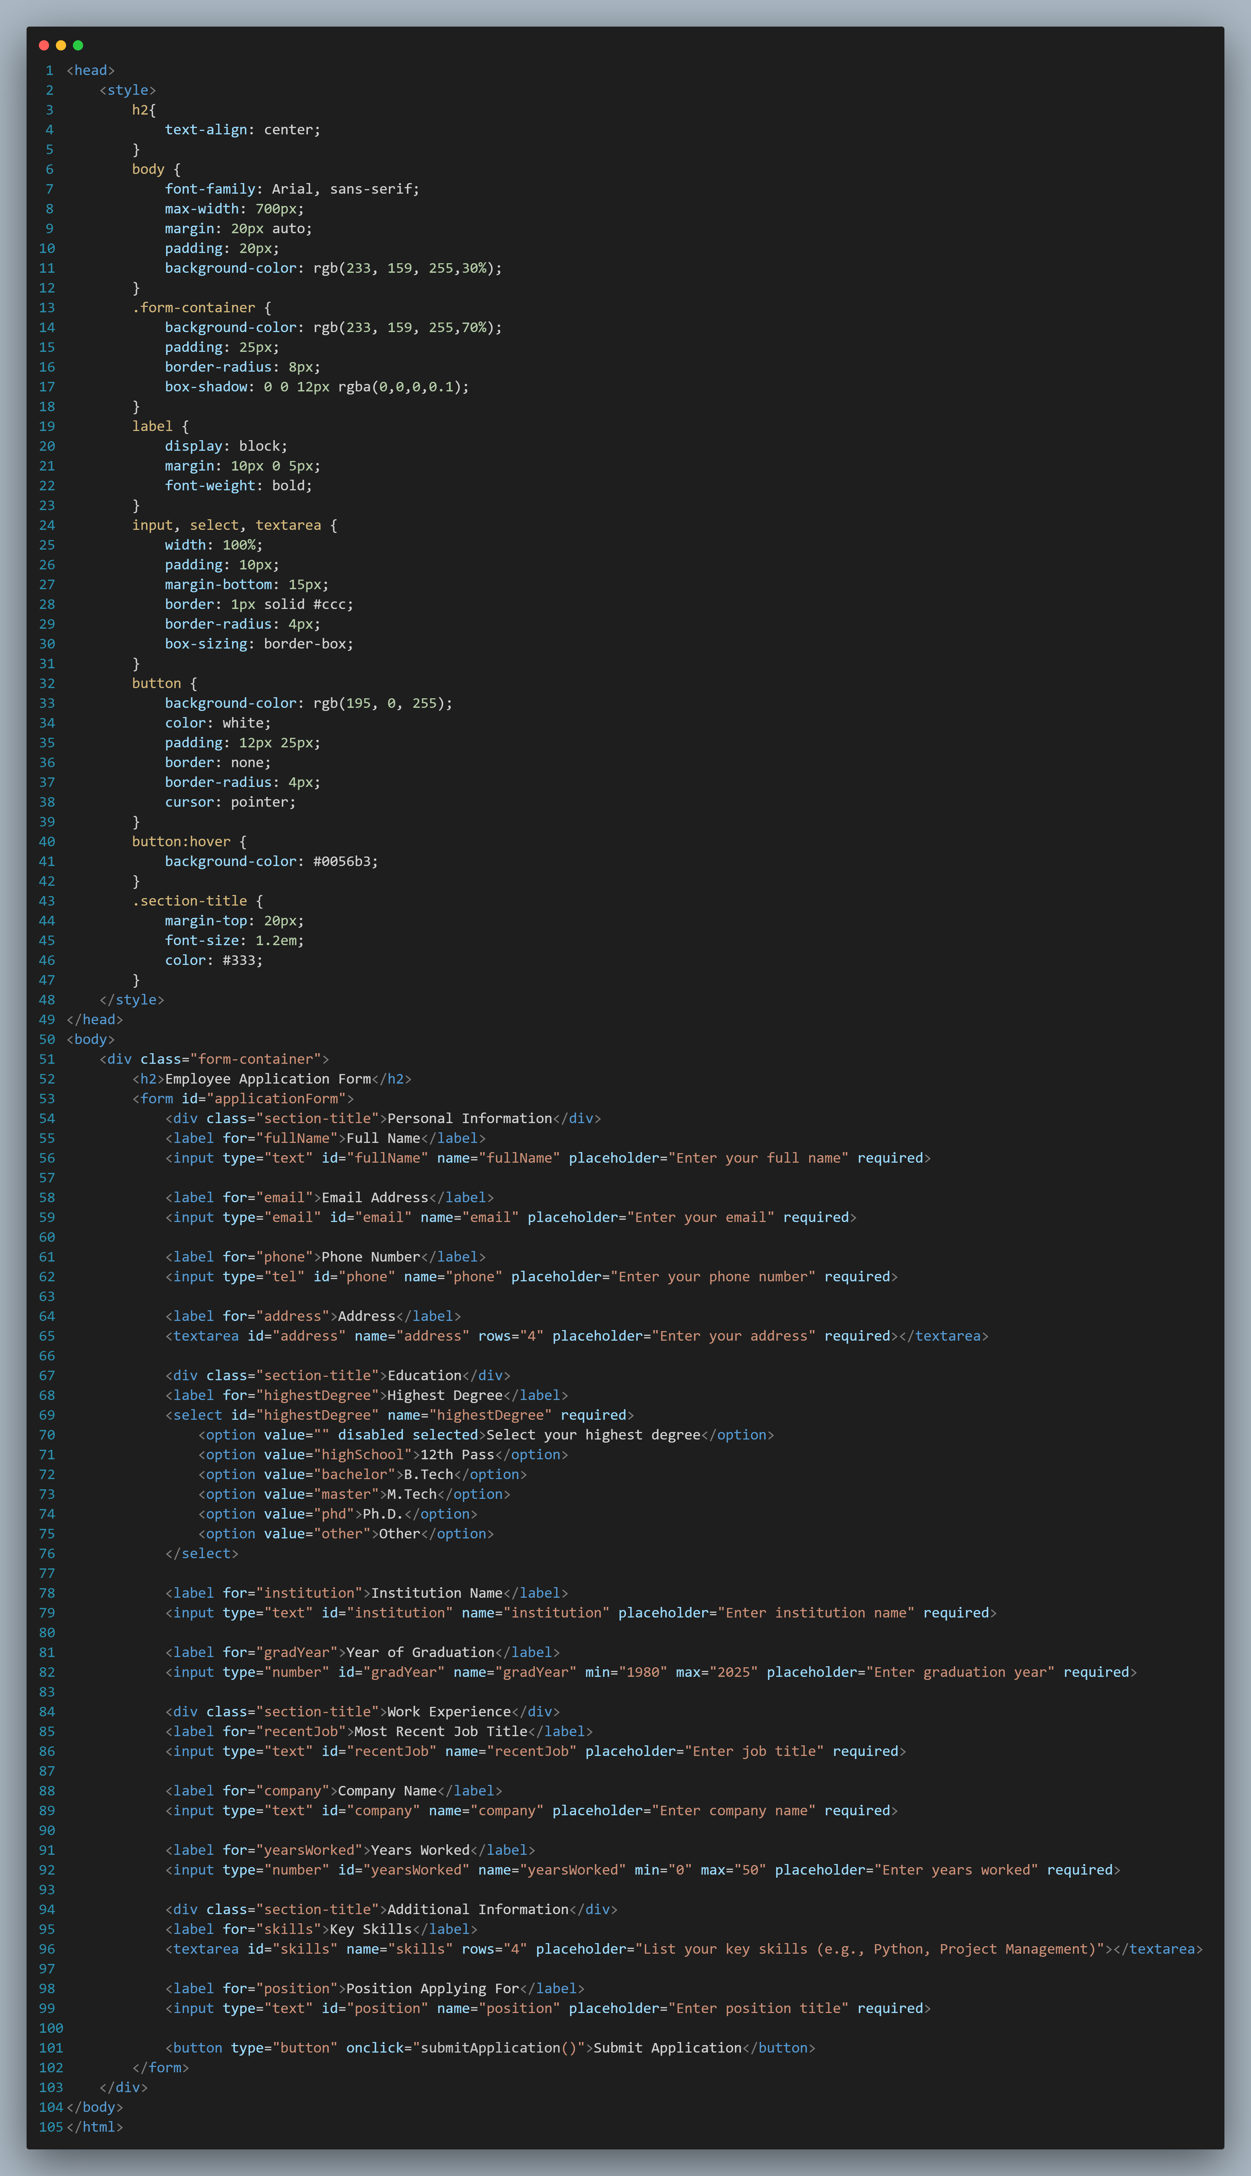

Result:

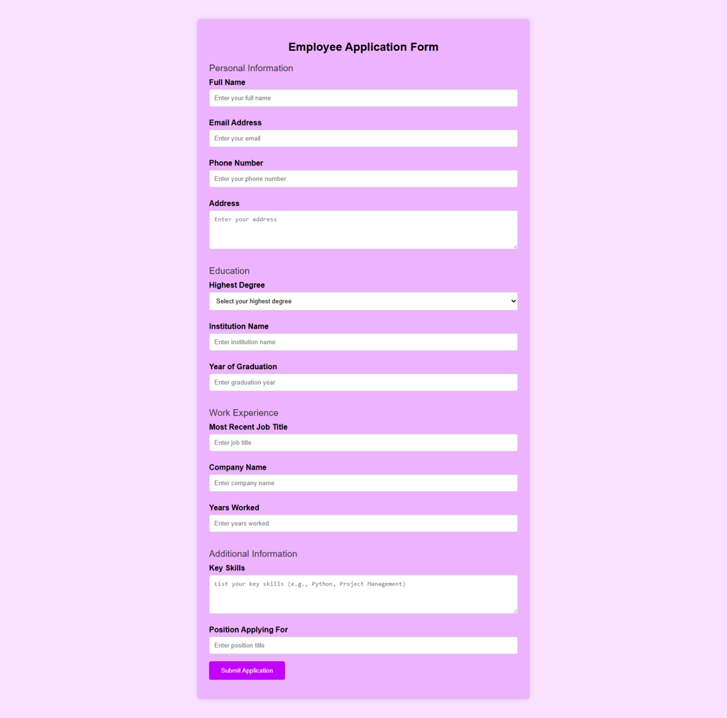

* Write HTML code to display student registration form.

HTML Code:

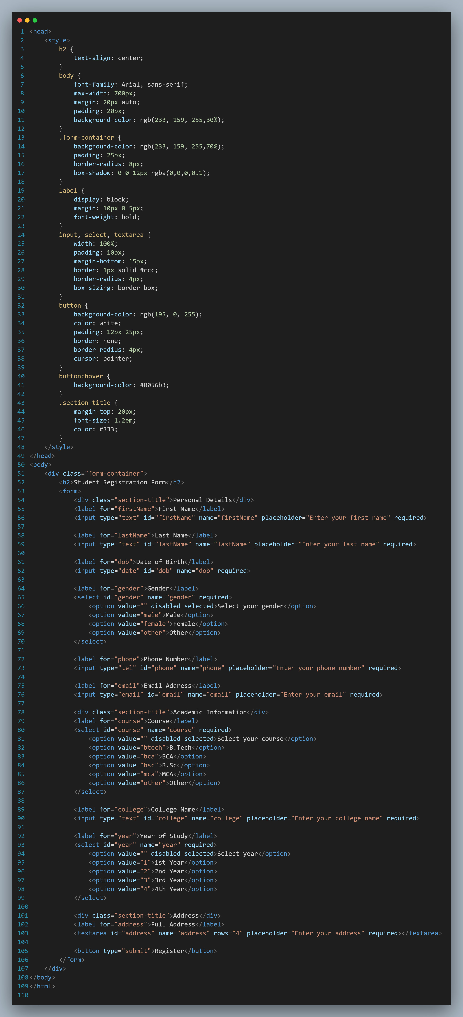

Result:

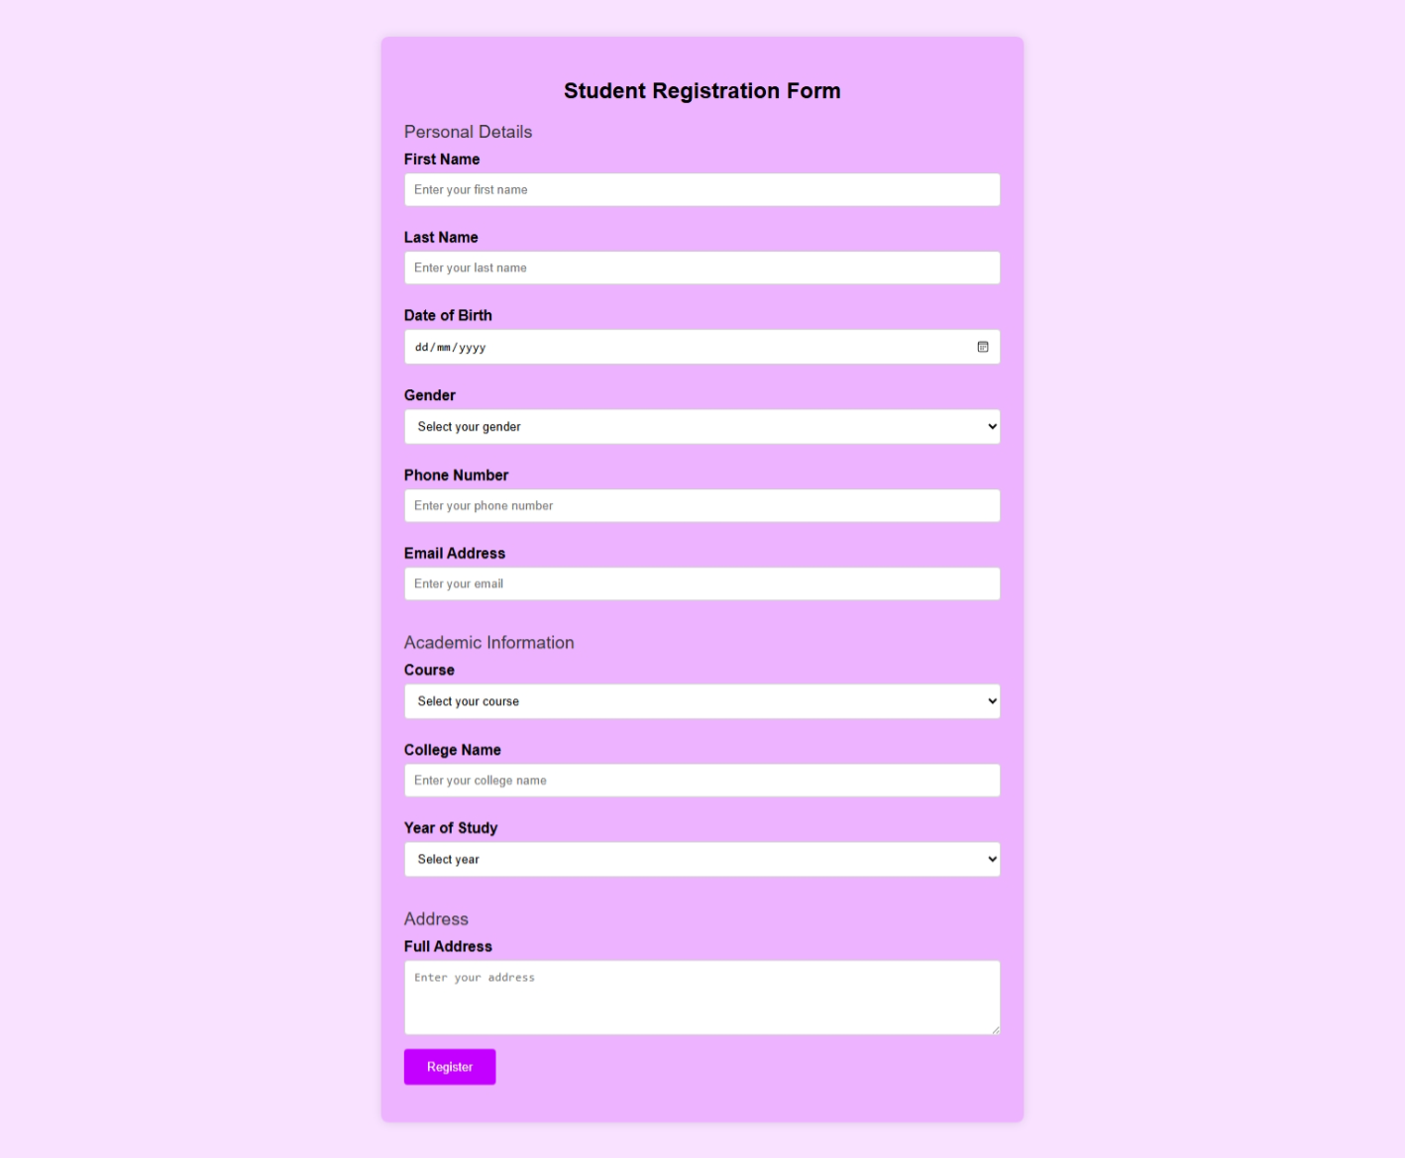

* Write HTML code to create an external CSS and implement it on shopping homepage.

HTML Code:

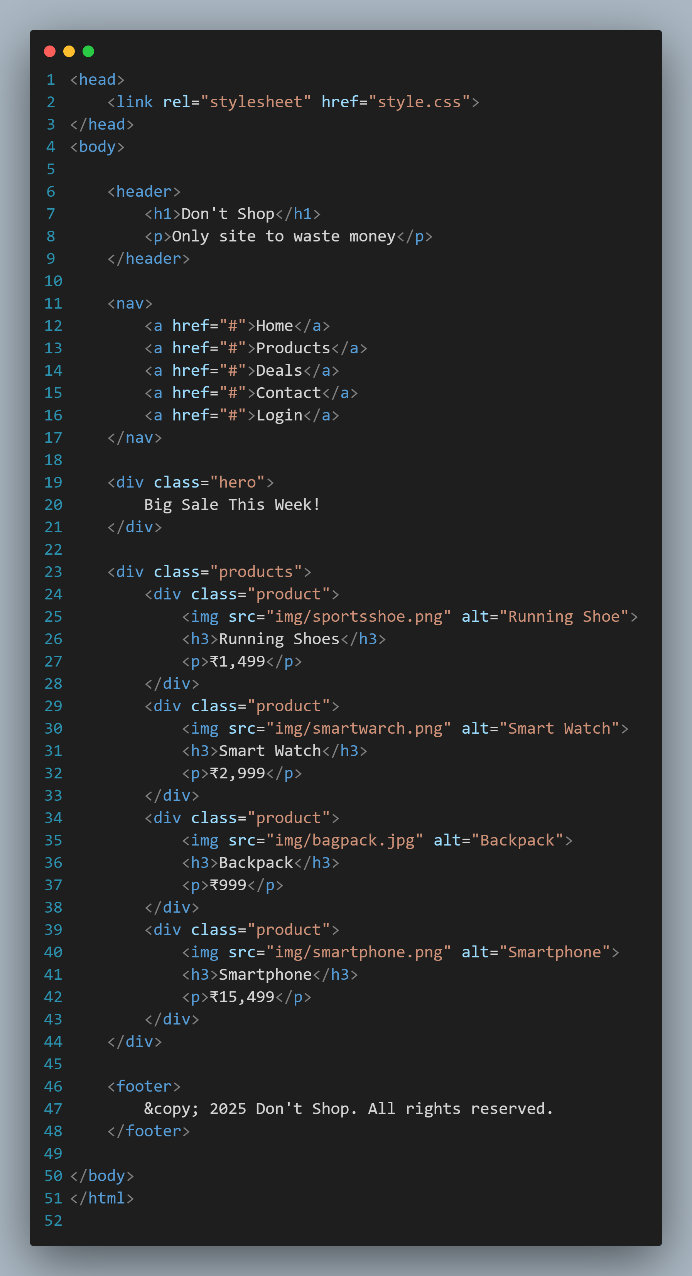

CSS Code:

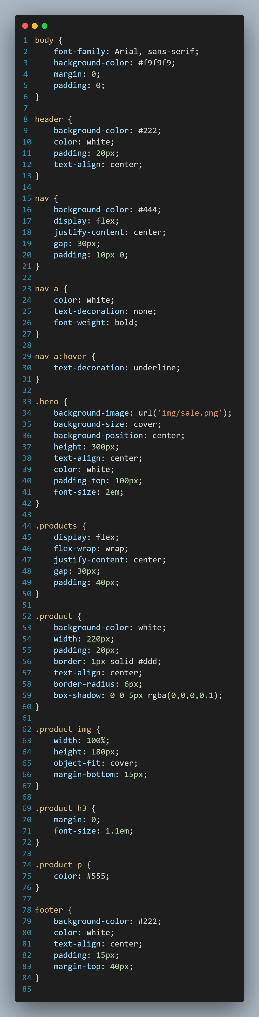

Result:



* Give an example of inline stylesheet.

HTLM code:

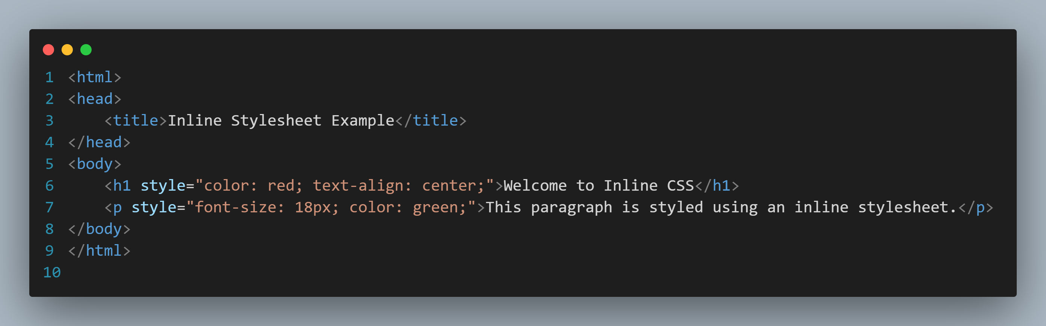

* Give an example of internal stylesheet.

HTML Code:

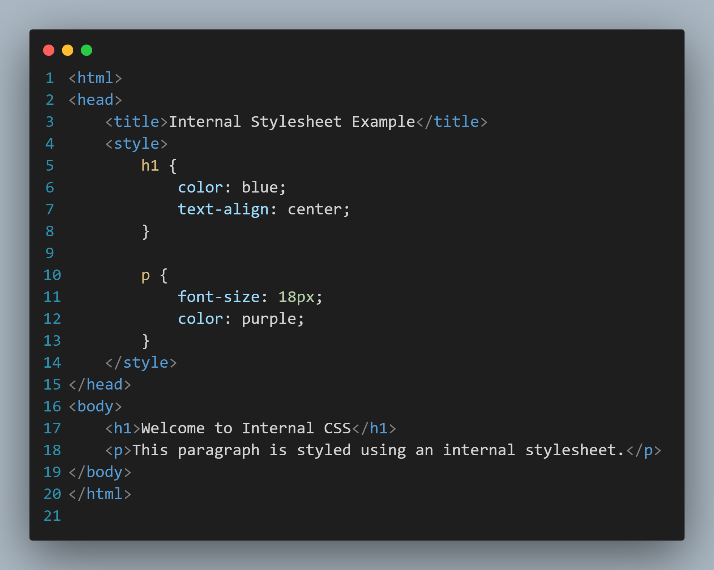

* Write HTML code to design the floating frame / inline frame of dimension 500×700 aligned towards the right.

HTML Code:

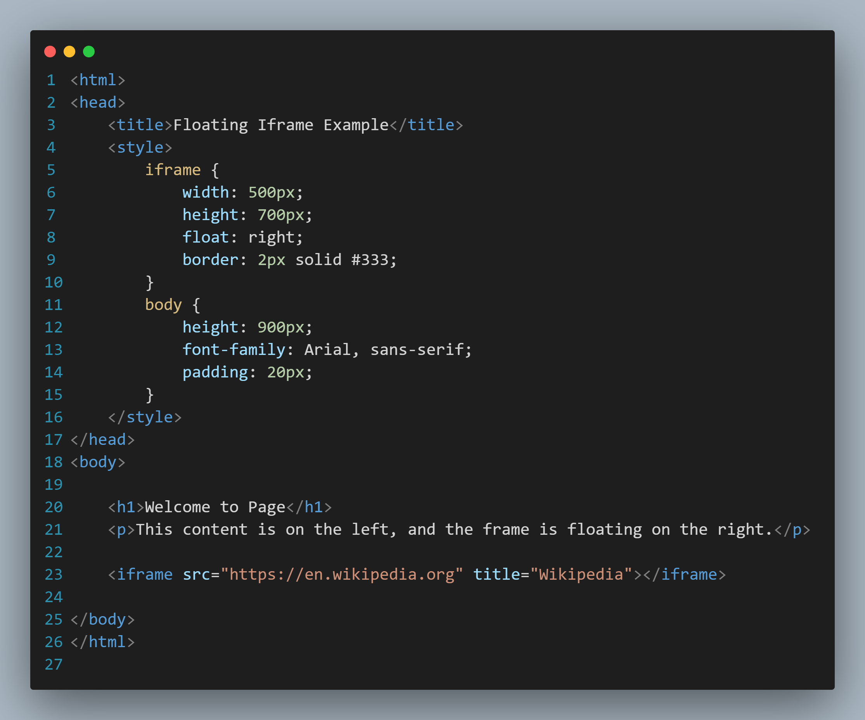

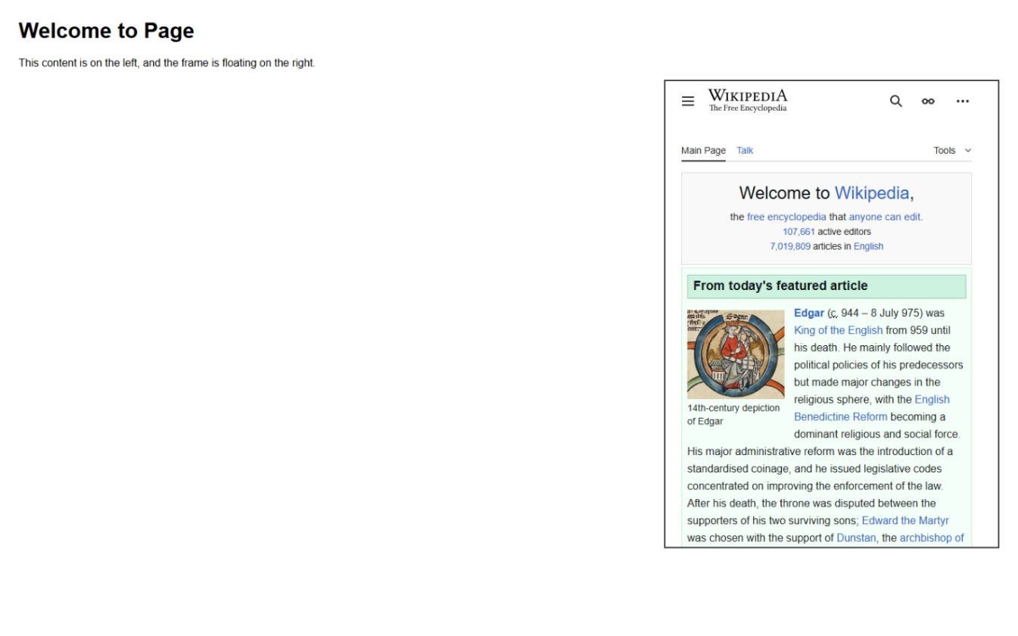Result: